Voltaire Dupo

Vdupo79@gmail.com

Abstract

This manual takes you thru the process of creating an automate system. It builds on current knowledge in electronics and electromagnetic machines and add the concepts of process of conceptualization, documentation and test and evaluation. The material uses examples as loose basis for decision making and process creation. It covers Human Machine Interface using two software based HMI.

Industrial Automation Manual

By Voltaire B. Dupo, ECE

Contents

Writers Notes 3

Consideration on Time and Effort 3

Future Work 3

Course Syllabus 4

Automation 8

Automation History 8

Why we Automate 11

Numerical Control 15

PLC Basics 22

Inputs and Outputs 22

Common Logic Functions 25

S1 (S2’) = BL1 25

OR Logic Function 26

PLC Ladder Diagram 26

26

XOR Logic Function 27

*PLC Ladder Diagram* 27

27

Additional Modules 30

*Timer* 30

35

Sample Problems 36

Mathematical Functions 39

MODBUS Basics 45

History 45

Virtual MODBUS Exercises: 47

Explanation of Virtual MODBUS Exercise 50

Activity 1. Modbus RTU Slave Implemented in Arduino using OpenPLC 51

Activity 2. Making use of the Input Registers 56

Human Machine Interface 58

Rules on Creating HMI 58

Advanced HMI steps on how to use it 59

Software Bench Testing your HMI 66

Migrating your Work from AdvancedHMI Solutions Workarea to an executable 70

Activity 1D: Connecting your AWDS Modbus, EEPROM, LCD to the HMI. 70

Using Winlog Lite 3.0 71

Preparation for Use and Opening the Program 71

Setting up Modbus communication 73

Project 2. Build your assigned project 83

# Writers Notes

This booklet was initially a set of written exercises for the students of DBCS written on the free time of the author not on the time extended and paid for by DBCS. The work presented is from the writer / engineer who had to come up with laboratory materials from a system that was without one for the class.

The original work is covered by an Attribution-NoDerivates 4.0 license which implies that the information here is not freely shared among people and can be used for commercial purposes in this form or in a more refined and edited form. No part of this work can be reproduced and distributed without the prior consent of the Author. That being said this copy is an authorized version that can be shared freely within the Institute of Biomedical Engineering and Health Technology staff, researchers and consultants for their own self education.



## Consideration on Time and Effort

There are of course similar modules online and you probably need around 4 modules or so to complete the same type of course. If each module where priced at around 20 USD per module without taxes. That would set you back around 4000 pesos and spend around 5-8 days figuring out how to connect each module to each other and write the materials. As such obtaining a copy of this book may be a bit more advantageous for any student/engineer.

## Future Work

Future work will be done to document using the OMRON CP1E and CP1H to do the some same sort of integration to complete a series that starts with Arduino MODBUS based Automation and Systems Integration and continues on to OMRON Based Automation and Systems Integration. Of course another separate Attribution-NoDerivates 4.0 License will be extended for that work but work will focus more documenting the process of how to use CX-Programmer to do the job.

Preparation for the Course

1. Readers going thru this material for non – audit purposes should at least have taken Basic Electricity, Electrical Wiring, Occupational Health and Safety.
2. Connect the PC/Laptop to the Net
3. They should download Open PLC Editor from <https://openplcproject.com/download/>
4. They should install Open PLC Editor.
5. They should update Open PLC Editor using [Alt] File -> Check for Updates
6. Press the Arduino Icon and Update the compiler dependencies

# Course Syllabus

|  |  |  |  |  |
| --- | --- | --- | --- | --- |
| Week | Lecture | Laboratory | Activity | Material |
| 1 | Introduction to Automation  • History of Automation and Operational Technology  • Reasons for Automation  Automation in Daily Life   * Goals of Automation * Automation and Society: Social * Economic Impacts of Automation | Elements of Automation  • Power Source  • Feedback Controls  • Programming (or Machine Programming) |  | Open PLC on Desktops  CX Programmer  Arduino Controller on PCB |
| 2 | Automation and Society  Automation and Employment  Automation and the Individual  Types of Automation Systems  • Hard Automation  • Flexible Automation | Applications of Automation  • Automated Production Lines  • Numerical Control  • Automated Assembly  • Robots in Manufacturing |  | E-gizmo Trainer |
| 3 | Applications of Automation  • Robots in Manufacturing  • Flexible Manufacturing Systems | Applications of Automation  • CAD/CAM and Computer Integrated Manufacturing |  | Desktop PC with KiCAD |
| 4 | Prelims Exam  Advantages and Disadvantages of Automation  Introduction to Low Cost Automation | Advantages Sequencer and Shift Register Instructions  • Mechanical Sequences  • Sequencer Instructions  • Sequencer Programs |  | PC with Livewire for Logic Circuits  Alexan Trainers for Logic Circuits |
| 5 | Advantages Sequencer and Shift Register Instructions  • Shift Registers  • Word Shift Registers | Developing Fundamental PLC Wiring  Diagrams and Ladder Logic Programs  • Electromagnetic Control Relays  • Contactors  • Motor Starters  • Manually Operated Switches |  | PLC Wiring Boards  Electronic Relay Modules  Open PLC  CX Programmer |
| 6 | Developing Fundamental PLC Wiring  Diagrams and Ladder Logic Programs  • Mechanically Operated Switches  • Transducers and Sensors  • Output Control Devices  • Seal-in Circuits | Converting Relay Schematics into PLC Ladder Programs  • Writing a Ladder Logic Program Directly from a Narrative Description |  | PLC Wiring Boards  Electronic Relay Modules  Open PLC  CX Programmer |
| 7 | PLC Installation Practices, Editing, and Troubleshooting  • PLC Enclosures  • Electrical Noise  • Leaky inputs and Outputs  • Grounding  • Voltage Variations and Surges | PLC Installation Practices, Editing, and Troubleshooting  • Connecting your Personal Computer and Your Programmable Logic Controller  • Program Editing  • Programming and Monitoring |  | PLC Wiring Boards  Electronic Relay Modules  Open PLC  CX Programmer |
| 8 | Midterms  PLC Installation Practices, Editing, and Troubleshooting  • Preventive Maintenance  • Troubleshooting | PLC Installation Practices, Editing, and Troubleshooting  • Preventive Maintenance  • Troubleshooting |  | PLC Wiring Boards  Electronic Relay Modules  Open PLC  CX Programmer |
| 9 | HMI Programming  • Introduction to Human Machine Interface  • Modbus Basics Standard Communication Protocol for Operational Technology  • Functional Objects/ Fixed Objects | HMI Programming  • HMI Programming using Advanced HMI Designer Software  • Program Test/ Simulation  • Downloading and Uploading of Program |  | PC With Advanced HMI and Visual Basic Installed |
| 10 | Failure analysis  • Preventive and predictive maintenance procedures  • Maintenance of mechatronics devices and systems  • Repair/ corrective maintenance of mechatronics devices and systems  • Inspection and testing of mechatronics devices and systems after repair | Project Making |  | PLC Wiring Boards  Electronic Relay Modules  Open PLC  CX Programmer  PC With Advanced HMI and Visual Basic Installed |
| 11 | Project Documentation |
| 12 |
| 13 | Finals Exam | Project Presentation |  |  |

Items Needed:

Desktop PC with Installed

* Open PLC (Open Source)
* CX Programmer (OMRON)
* KiCAD (Freeware)
* Arduino IDE (Open Source)
* Livewire Simulator (Trial Version)
* NB Basic Software (OMRON)
* ModScan 32(Freeware)
* ModSim 32 (Freeware)

Materials:

* E-gizmo Trainer – 16 Units
* Alexan Trainer – 18 Units
* PLC Wiring Boards – 9 Units
* CP1H – 4 Units
* Omron Relay Units
* 12v TTL Relay Modules – 4 Units in Laboratory carry over from Automation Systems Integration.

Materials Needed Not in Laboratory

* Fixed 12v Power Supply - 6 Units
* Arduino Nano Board – Count Required Based on How many students there are this is considered as consumable item this will enable students to develop solutions individually using Open PLC if we want them to learn the material better this would be necessary so that time on the Omron PLC can be really shared but it will not impact learning and time on the simulator for them.

# Automation

## Automation History

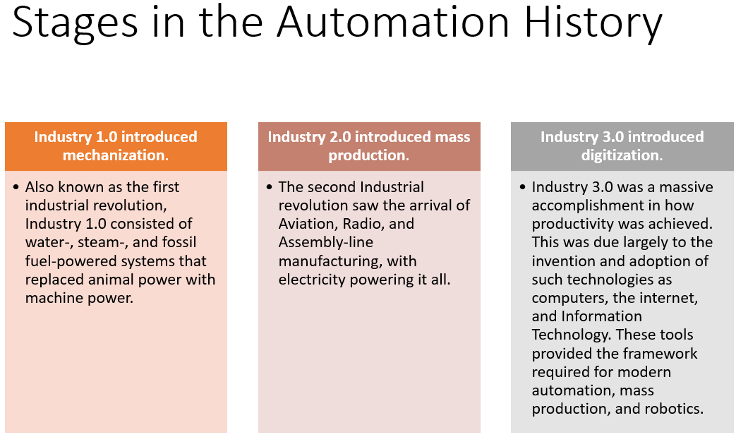











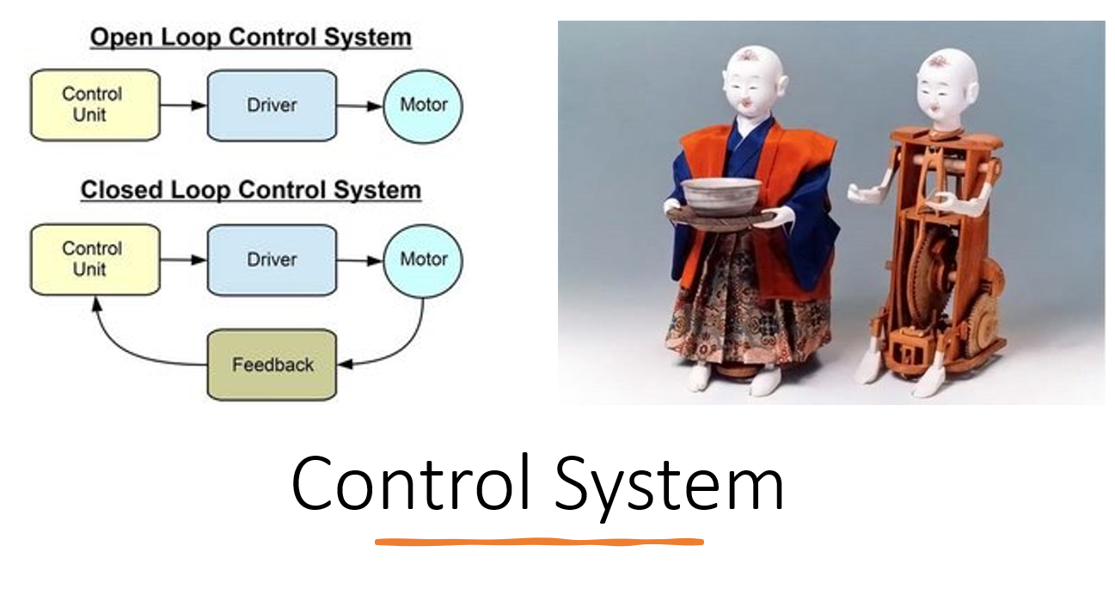

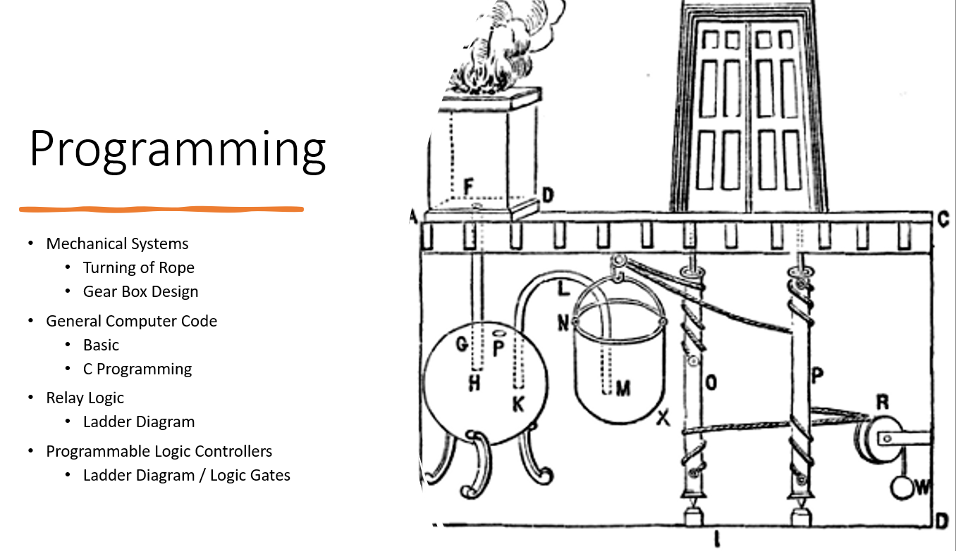

## Why we Automate

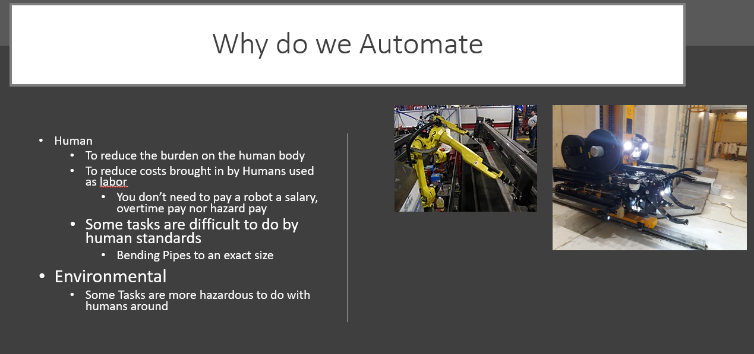

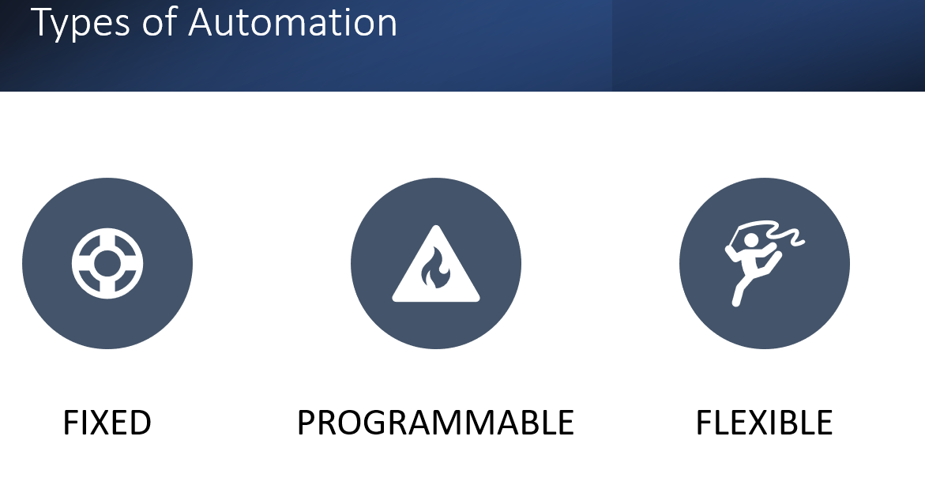

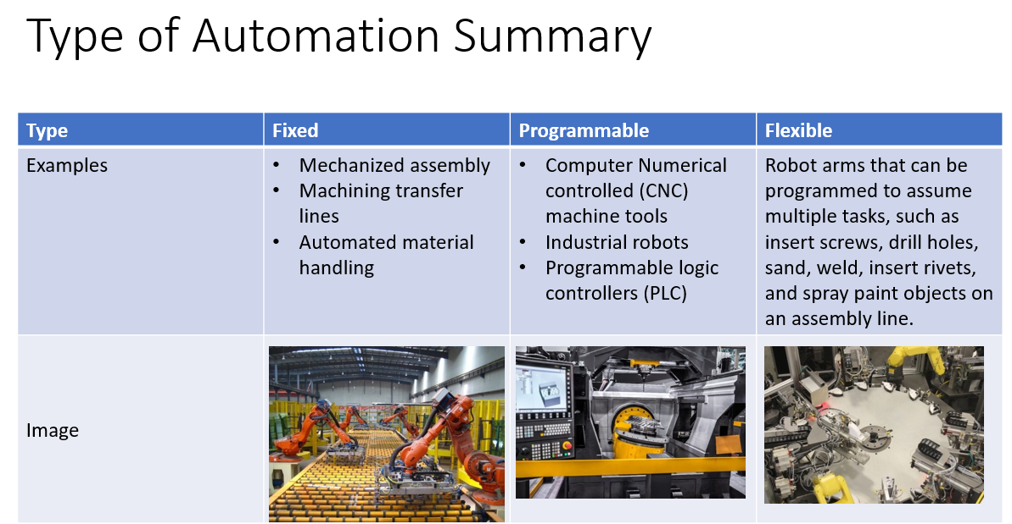

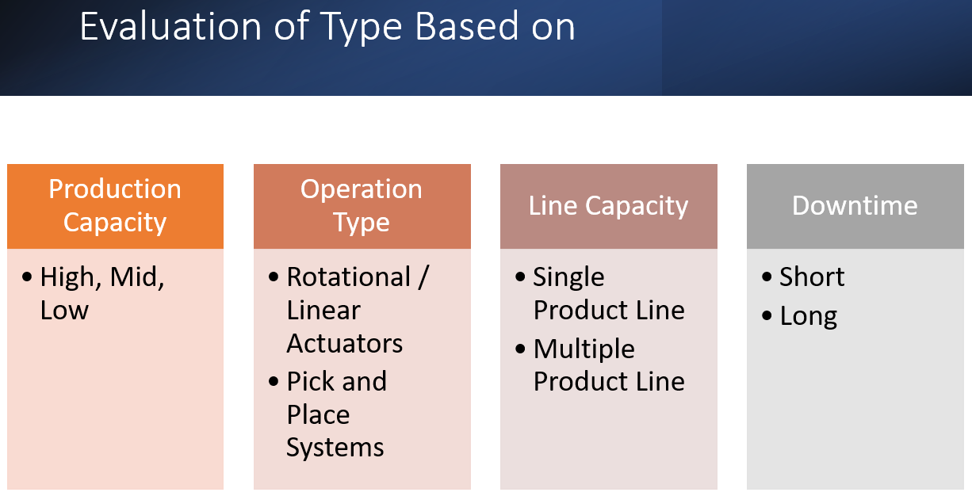

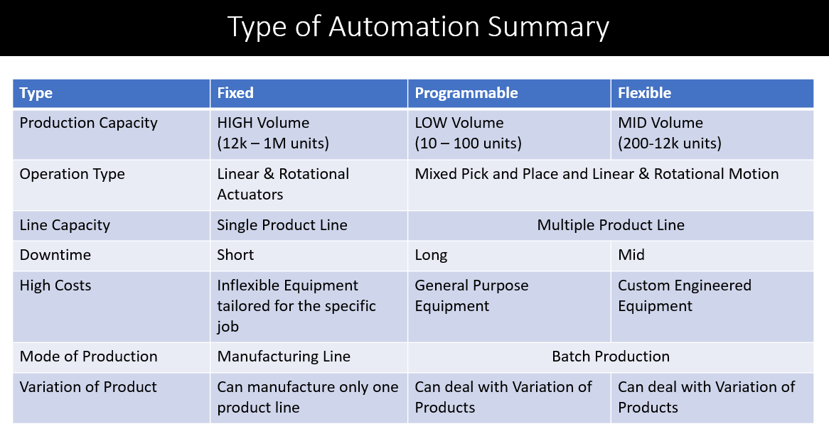



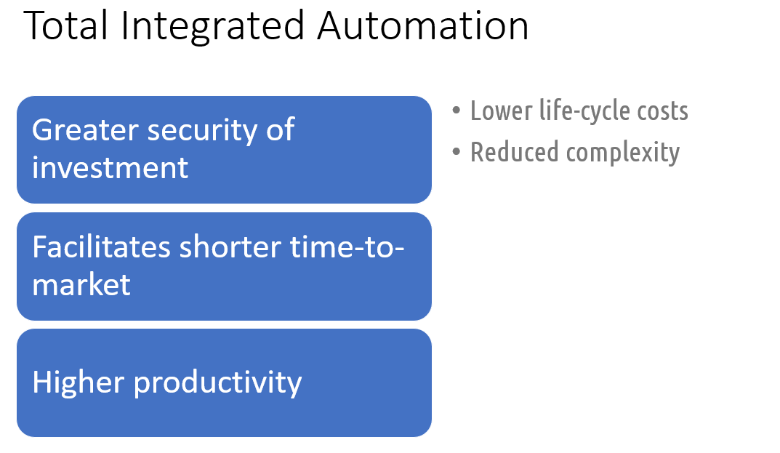

## Numerical Control

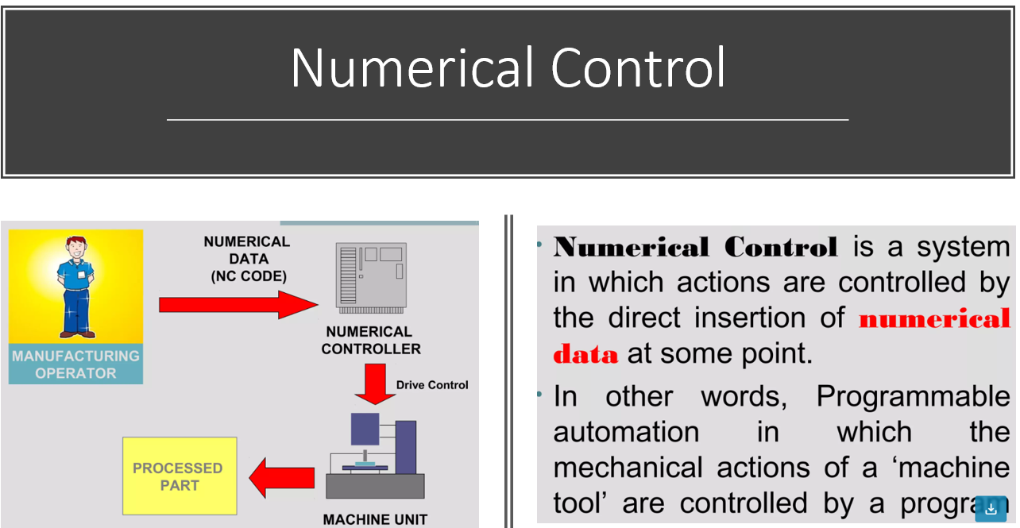

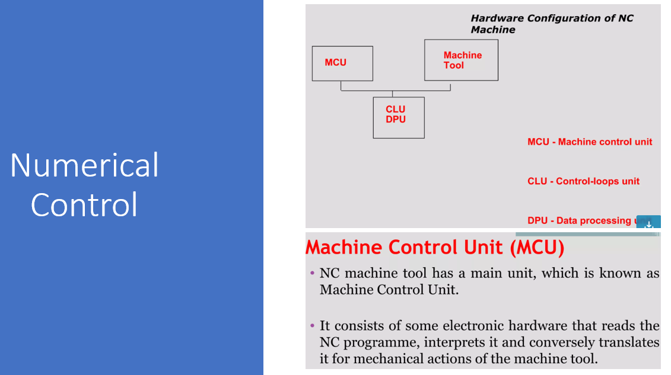

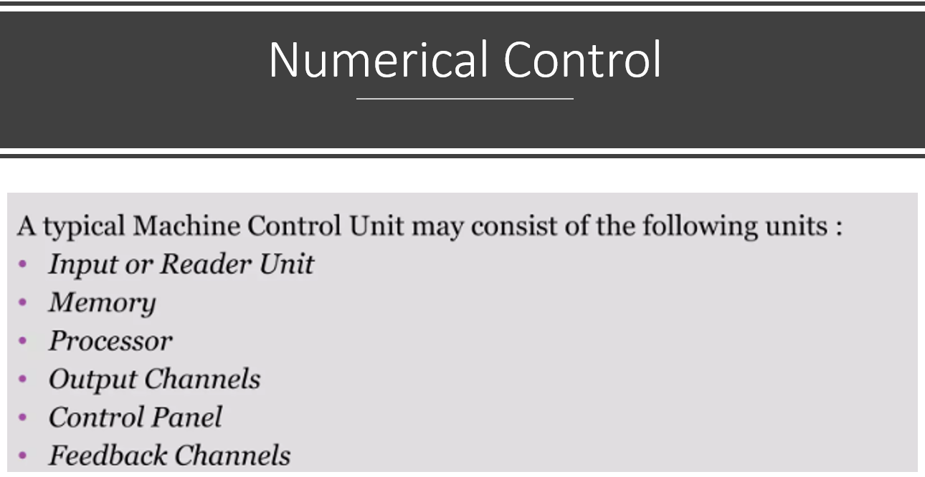

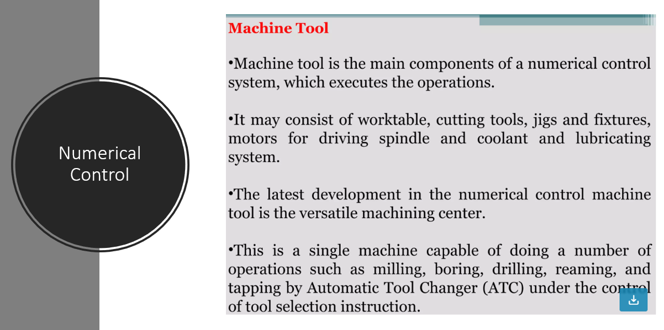

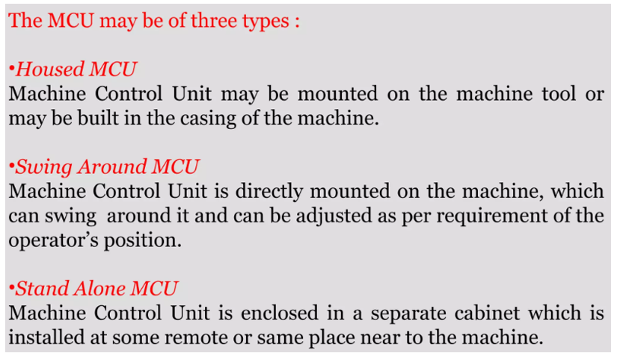

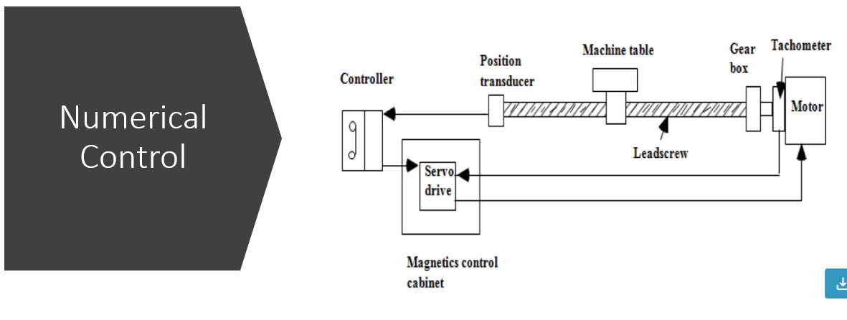



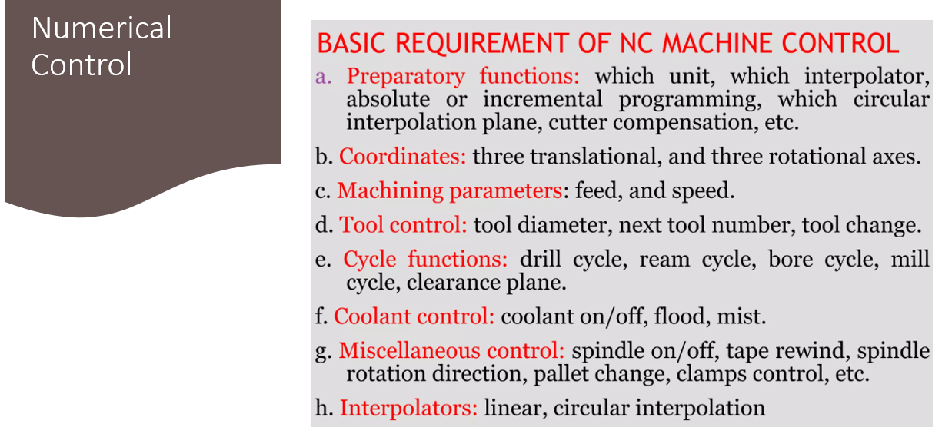

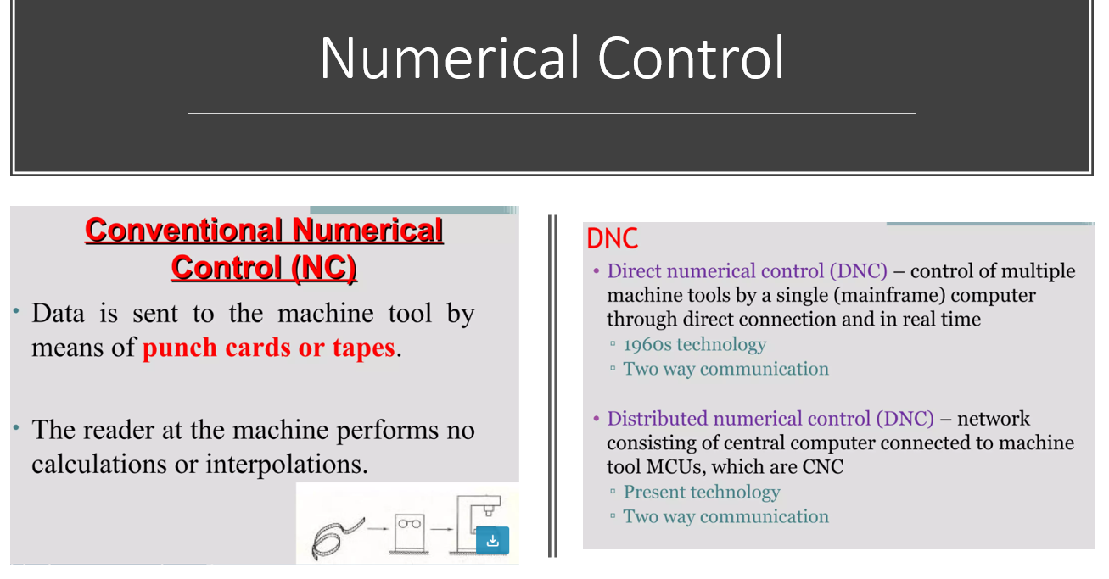

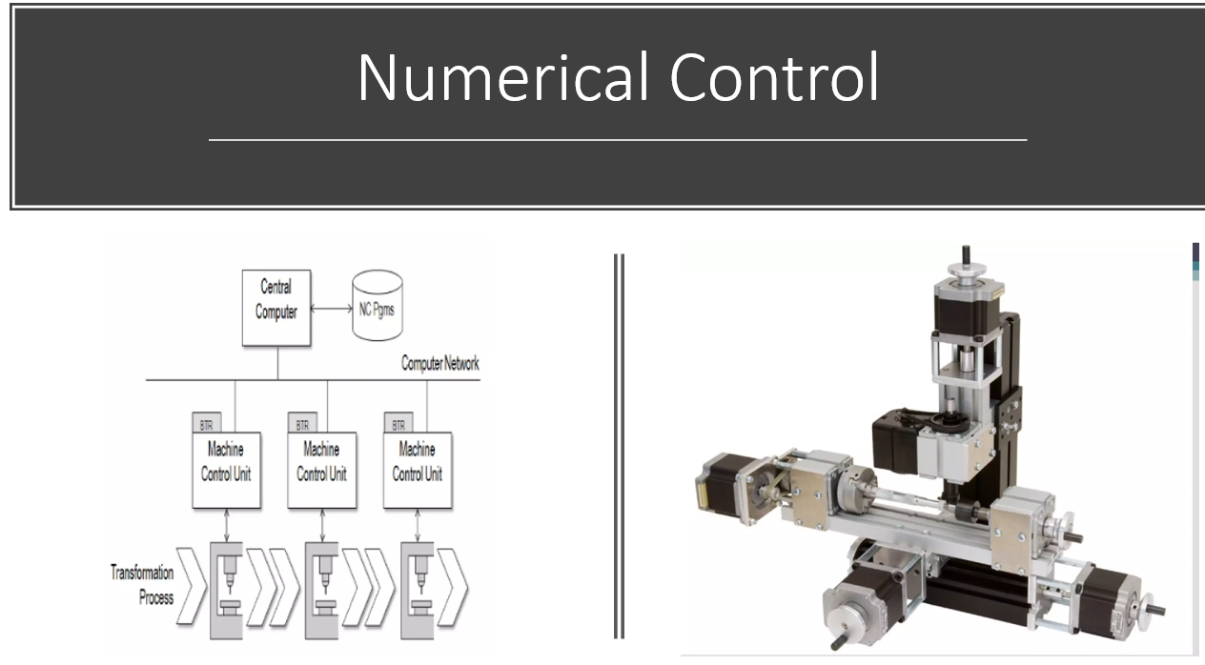

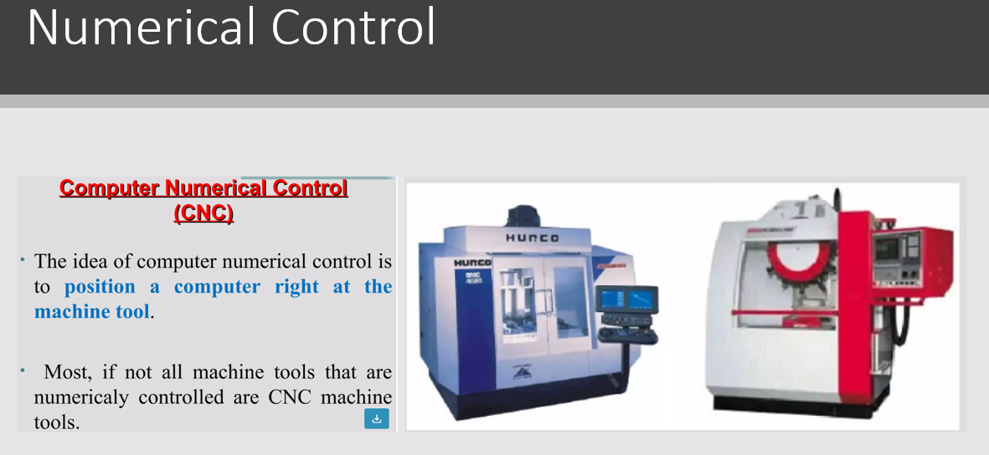



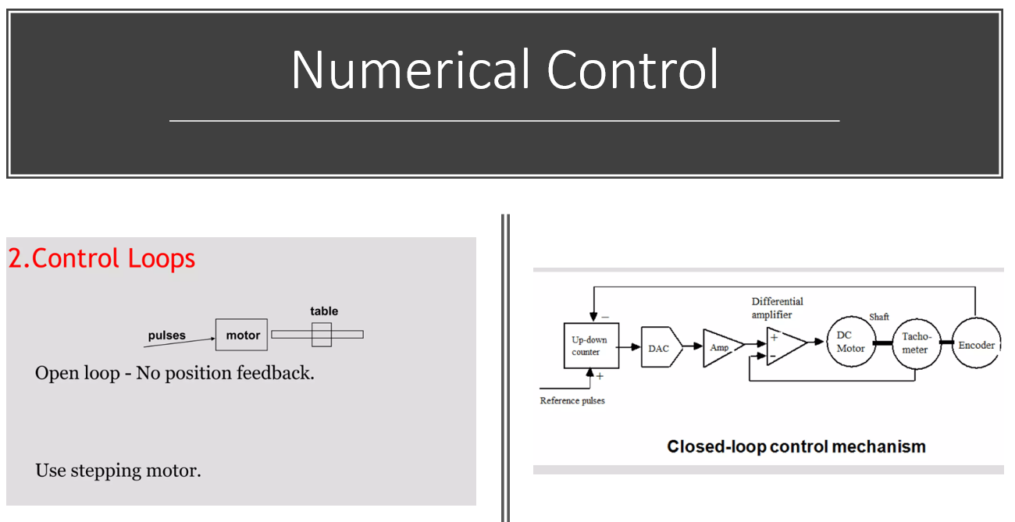

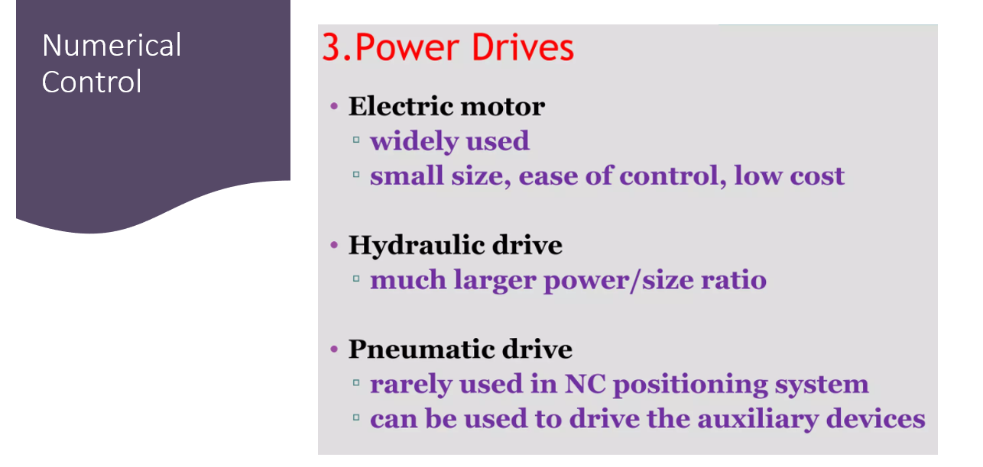

# PLC Basics

We need to explore the relationship with Digital Electronics and Ladder Diagram Elements before we proceed to see how these structures are really similar to each other.

### Inputs and Outputs

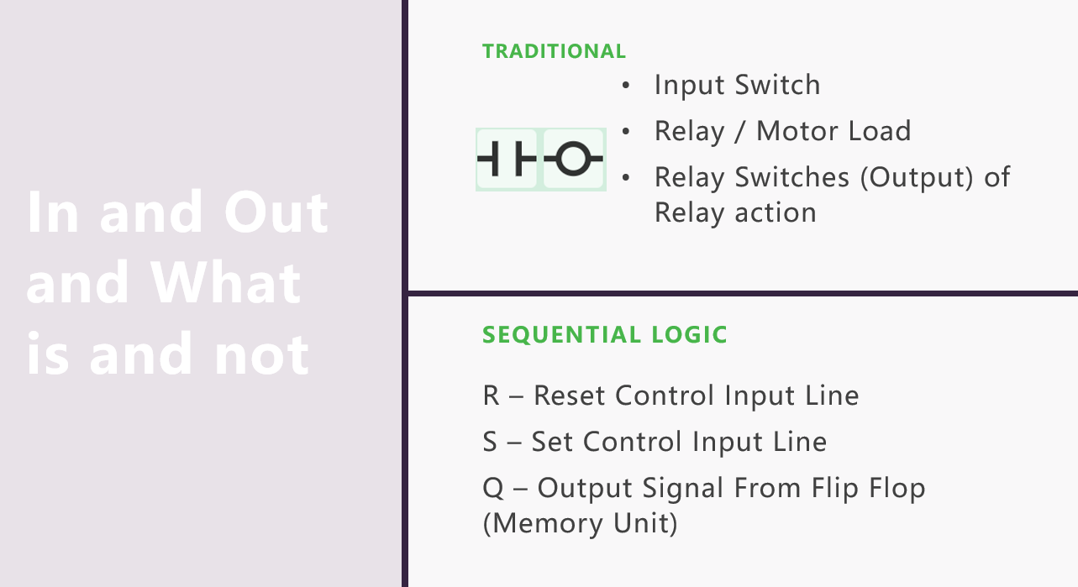

In Open PLC this are items marked by the symbol 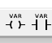

Take note you have to initially assign the tags to use with these structures and they are defined as “Boolean” Variable. You can to this by tapping on the + Icon

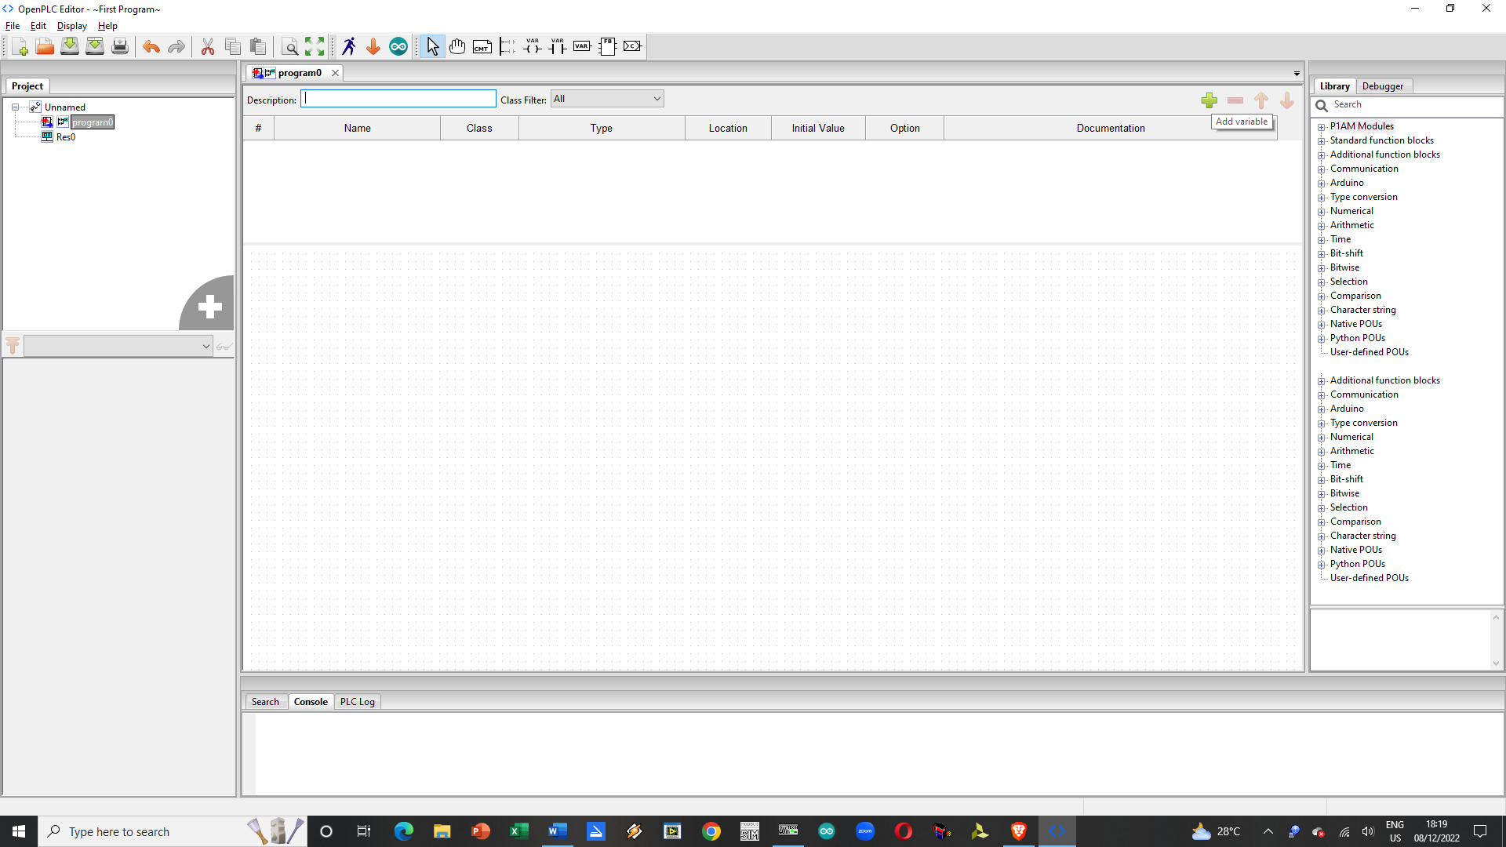

You can then add the details like Name of the Tag its Class which is Local and its Type.

You can change the type by clicking on the Type 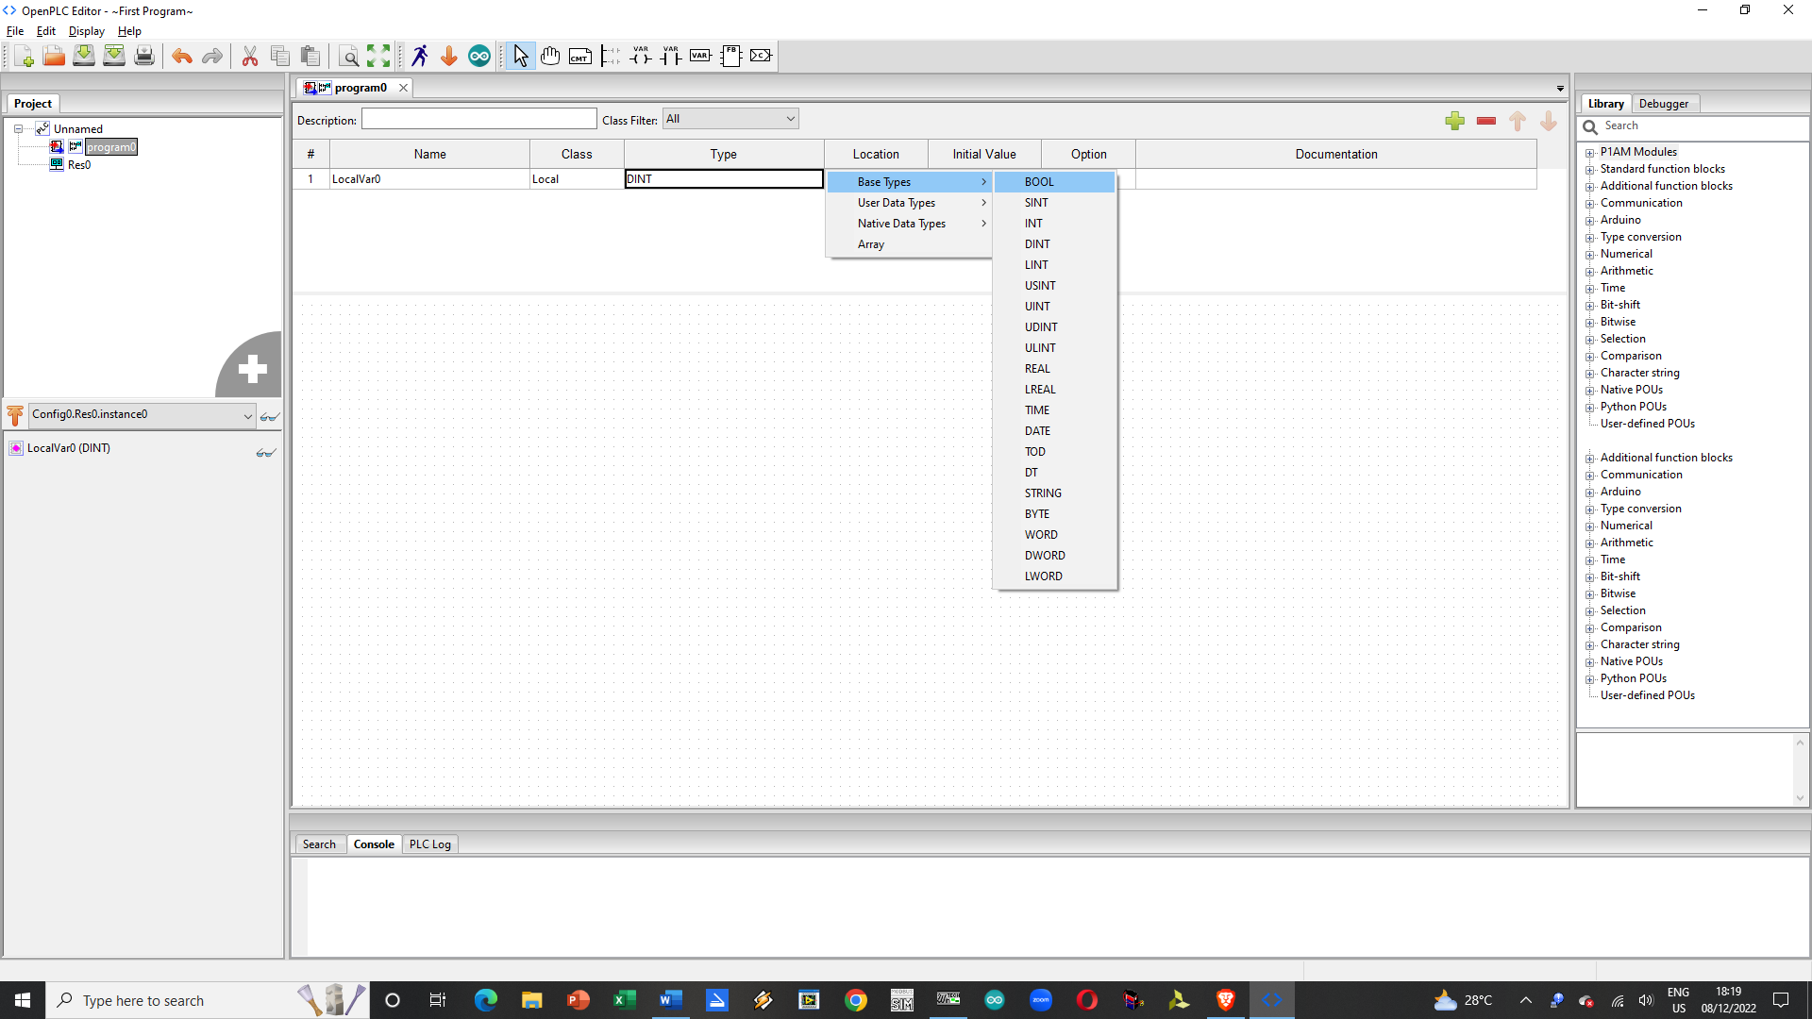

Make Sure to Assign the Location Values set on this Table below

Table . Location Values for Inputs and Outputs

|  |  |  |  |
| --- | --- | --- | --- |
| Pin | Location Value | Function | |
| Input | Output |
| D2 | %IX0.0 | X |  |
| D3 | %IX0.1 | X |  |
| D4 | %IX0.2 | X |  |
| D5 | %IX0.3 | X |  |
| D6 | %IX0.4 | X |  |
| D7 | %QX0.0 |  | X |
| D8 | %QX0.1 |  | X |
| D12 | %QX0.2 |  | X |
| D13 | %QX0.3 |  | X |

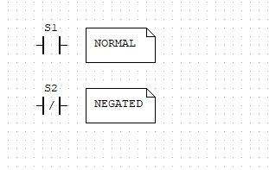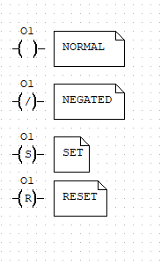

Common Input Options Common Output Options

You can select the type of input or output you want at the initial assignment stage

## Common Logic Functions

#### AND Logic



S1 (S2’) = BL1

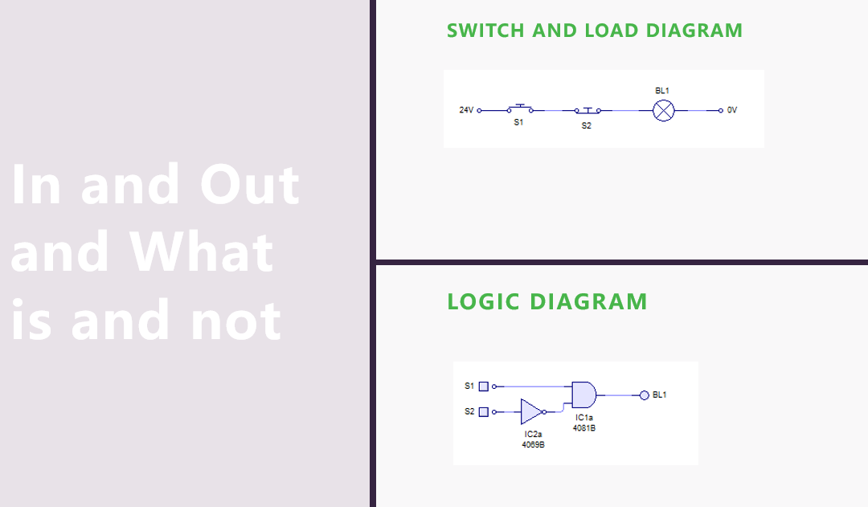

OR Logic Function

### PLC Ladder Diagram

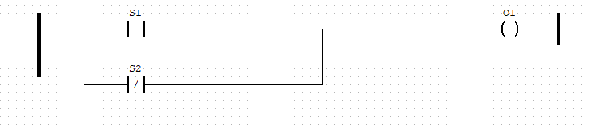

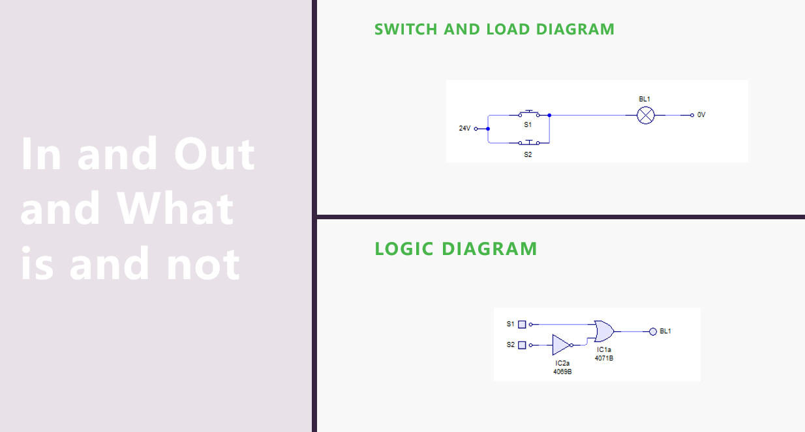

XOR Logic Function

#### PLC Ladder Diagram

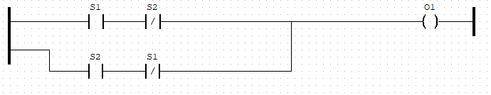

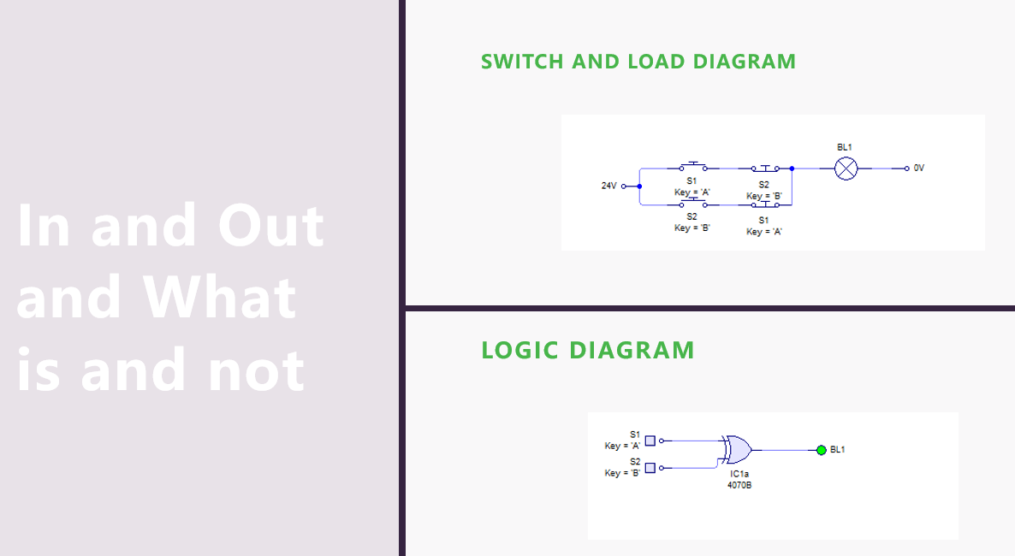

Functional Blocks - Alternatives to Logic using wires

Click on this Icon to Start Creating Functional Blocks 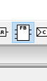

Click on the Workspace the options should appear

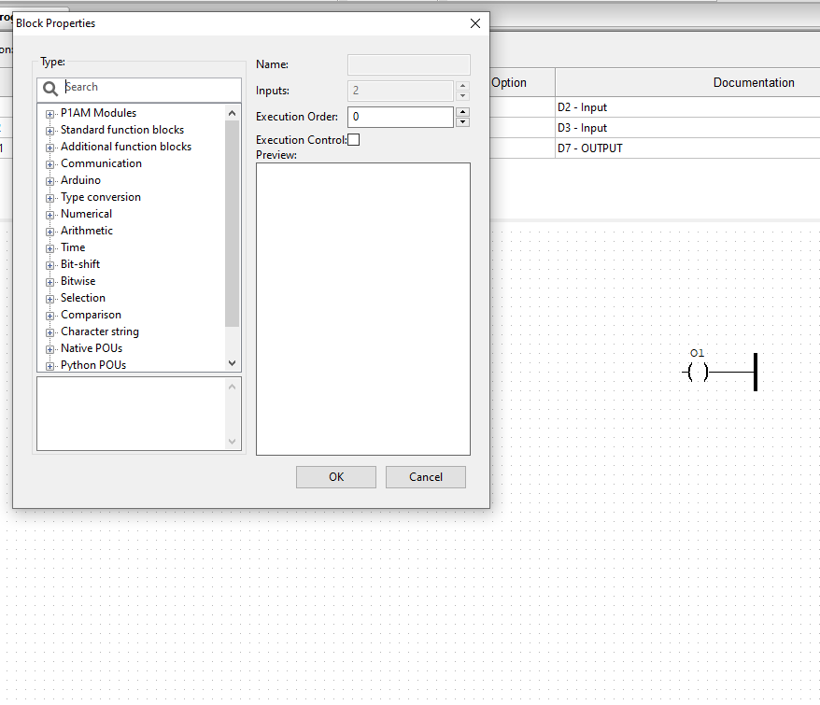

Click on the Bitwise entry

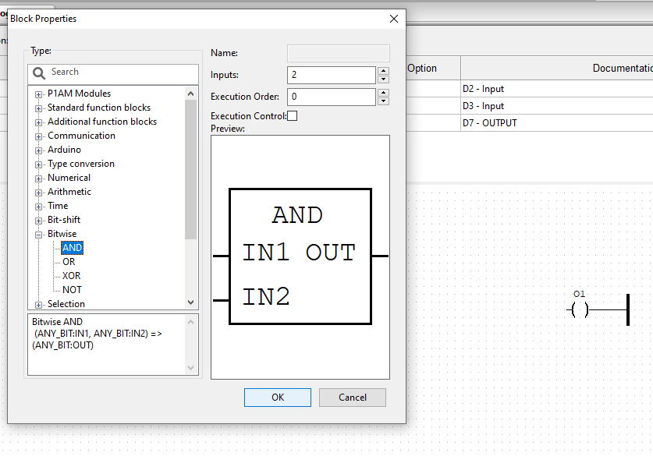

Select the Appropriate Gate and Press OK to Finish the Selection

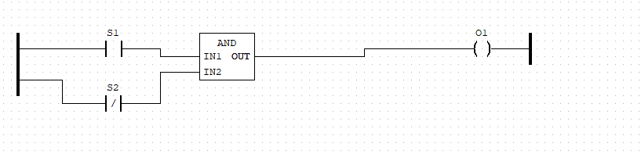

Is the same as



This is a better process when making XOR Operations since you need only to create the two input signals and the gate as shown below:

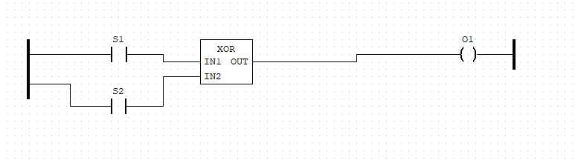

Is the same as



Note that S2 is Normal Not Negated in the XOR Functional Block Implementation

Additional Modules

#### Timer

Timer Modules / Functional Blocks are added if you want a specific delay in turning on / off signals

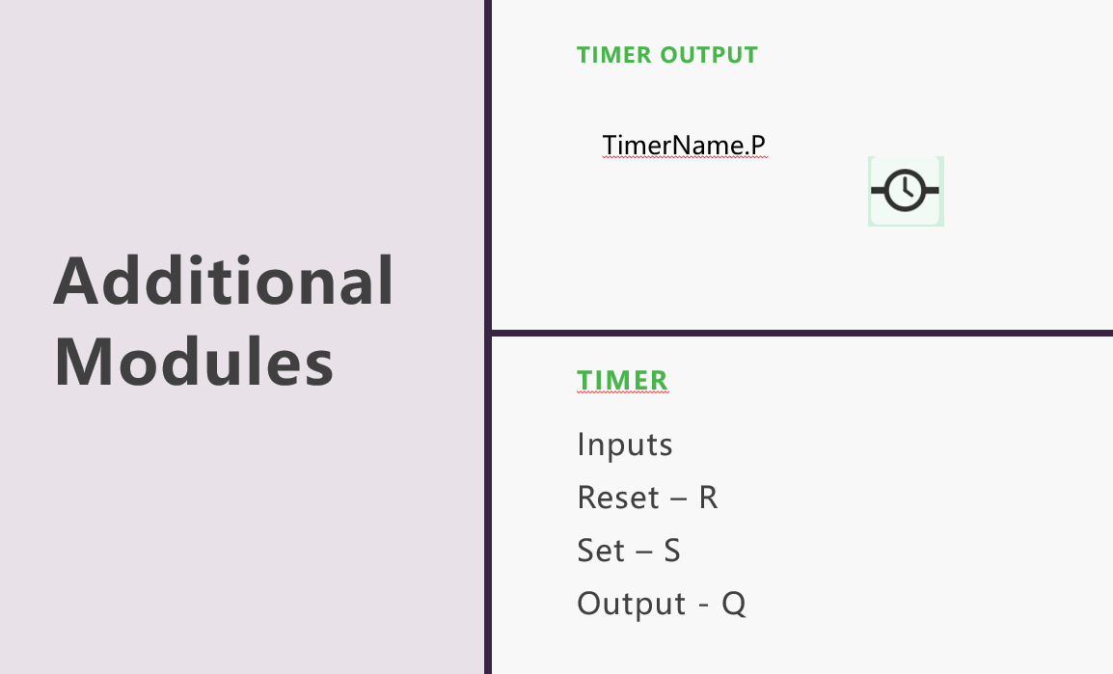 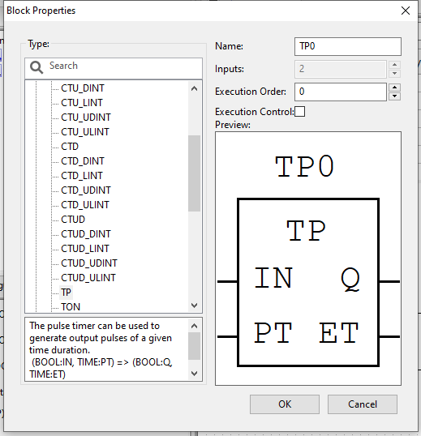

This can be found on the Functional Blocks under Standard Blocks TP

We can wire the inputs we have as such to control the timer

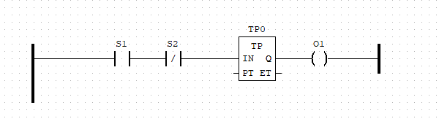

Notice the values of PT and ET are still Empty.

PV stands for Pre-set Time and CT Stands for Current Time.

We need to assign values to them we can do this by using the variable icon 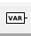

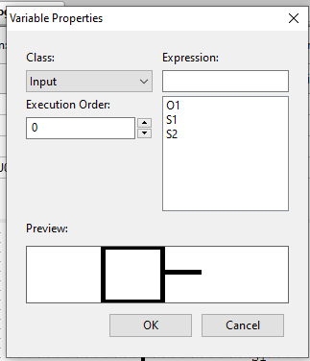

We can type in T#<xxxx><uuu> where xxxx is the number of milliseconds we want the reference to be. While uuu stands for the time unit we use there is mS and S to choose from.

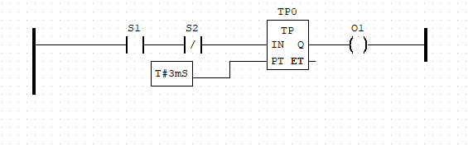

For CV we instead use the add variable + to add a new variable that is local with Type Time. We then use the VAR Icon to add in a new Variable but this time we choose Class Output and the Expression used is the new container we made for the number.

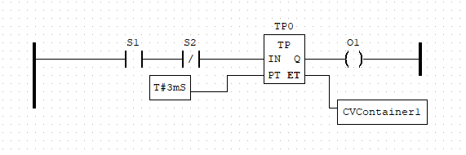

Pulse Timer (TPx) Blocks set the output high once triggered but it lasts only as long as the Pre-set Time value is before it powers down the output to low.

#### Counter

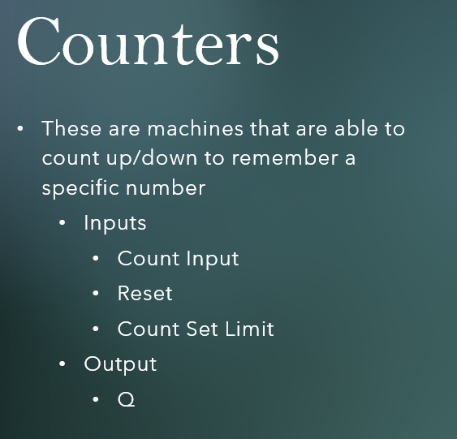

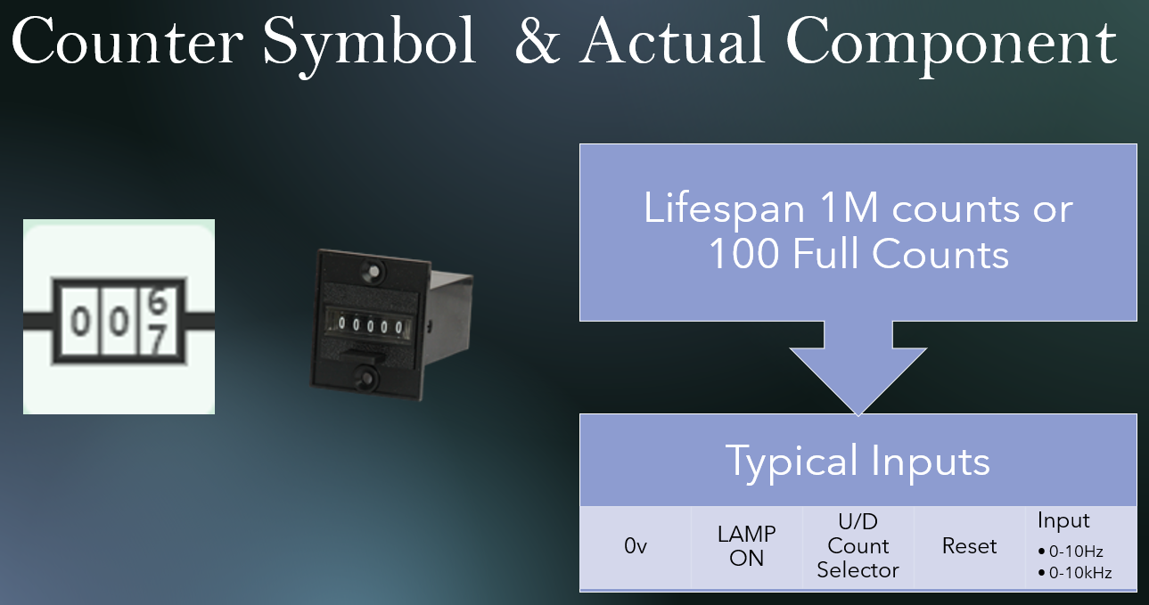

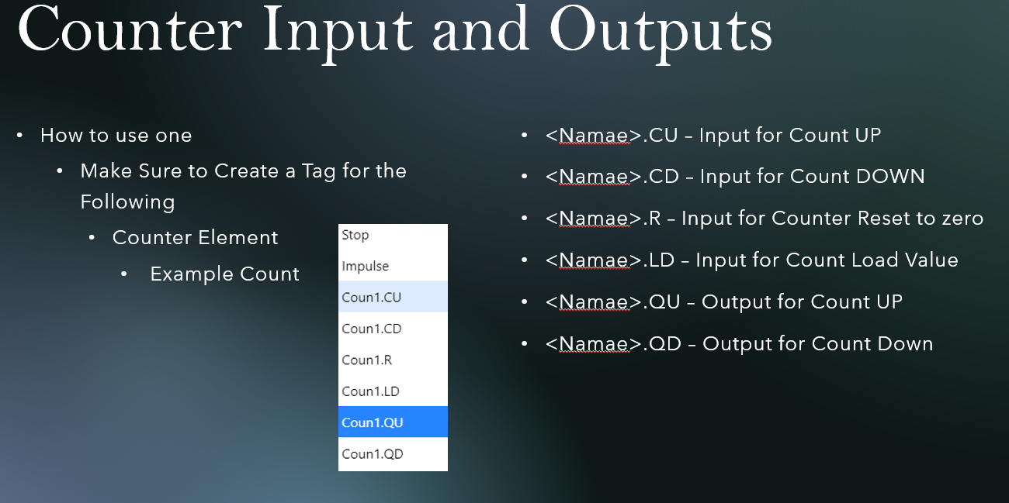

#### Counters For Open PLC

Set by using Functional Block (FB) it can be found under Standard Functional Blocks

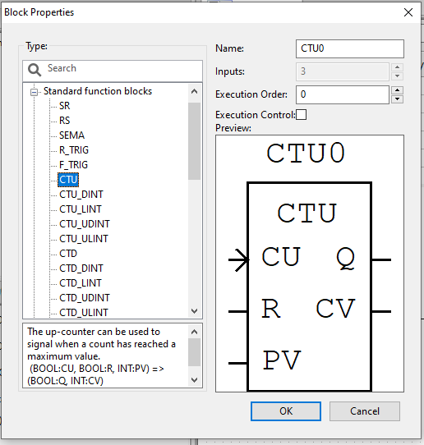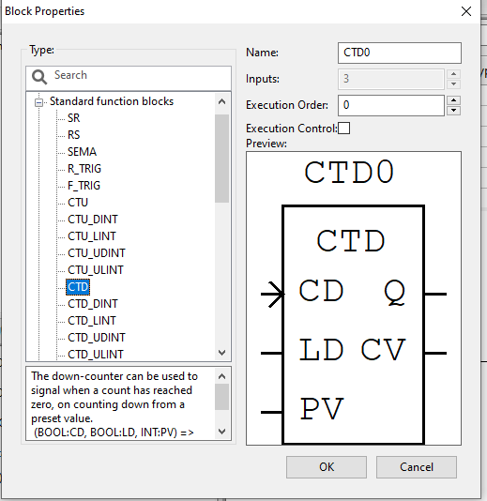 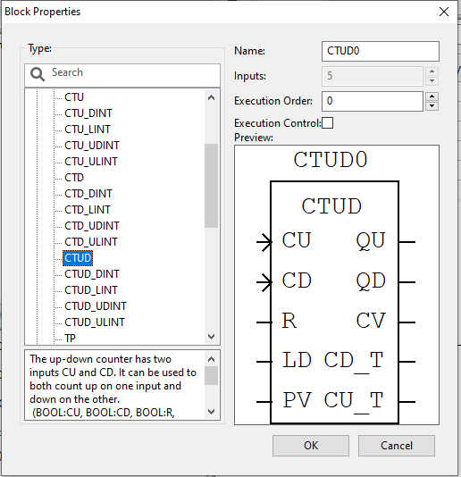

There are three kinds common to most PLC Programmers they are Count Up, Count Down and Count Up-Down.

##### Count UP Function Block

For every CU Signal held to high or Positive or Negative Edge the function block counts one and adds to the CV value.

If the Desired Preset Count is reached then the Q for Count UP (CTU) Functional Block or QU for Count Up-Down (CTUD) is set to high. If the value isn’t reached then Q or QU is set as Low.

##### Count Down Functional Block

Count Down Timers differ in operation since you need to load the pre-set value using the LD input held to high this in turn makes the current value equal to the pre-set value. Once Loaded move it to counter mode by making LD equal to low.

For every CD Signal held to high or Positive or Negative Edge the function block deducts one and to the CV value. If the current value count reaches 0 the QD output is held high.

R is the reset signal to make the current value move back to the 0 state this is similar to the LD function of the CTD functional block that loads the pre-set value just the CTU block preset value for CV is 0 when R is held to logic 1 or high.

To enter a Preset Value use the Variable Functional Block and type in the number of count you need to get achieve before the counter is turned on.

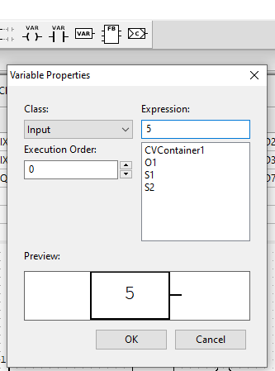

Your CV Container should be set to INT as its type. Then use the Variable Icon and select the CV Container

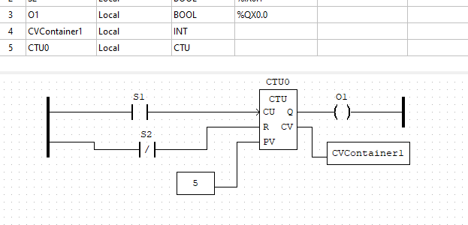

### Sample Problems

##### Problem 1

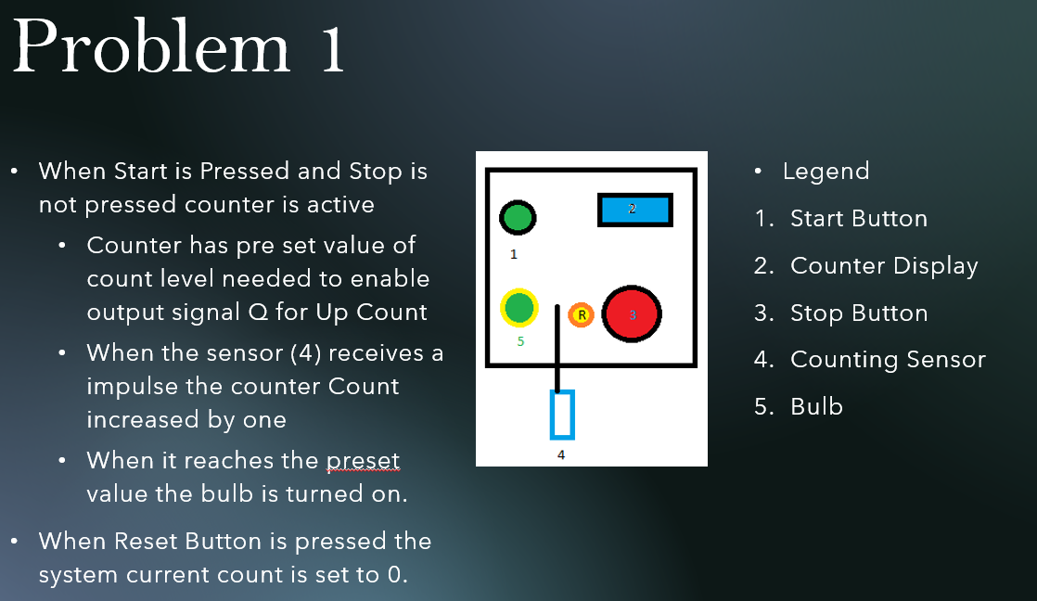

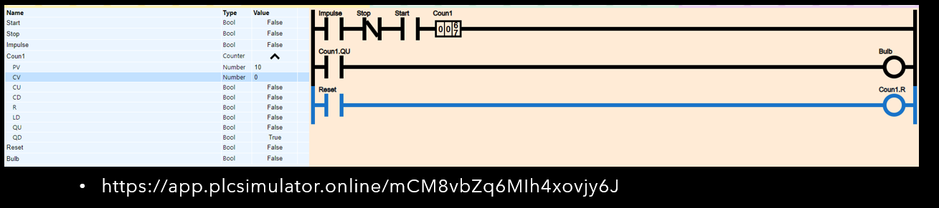

##### Problem 2

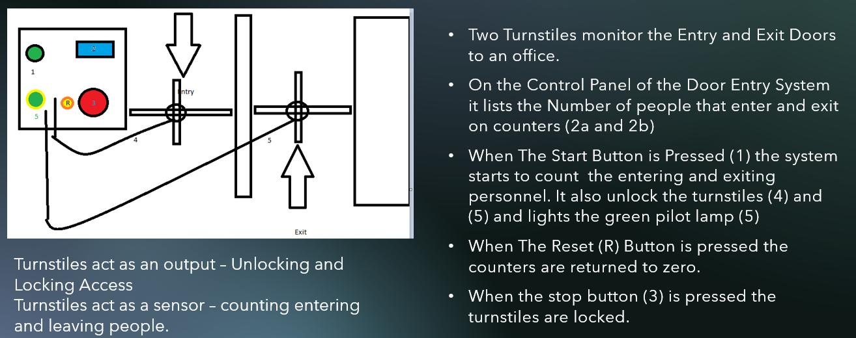

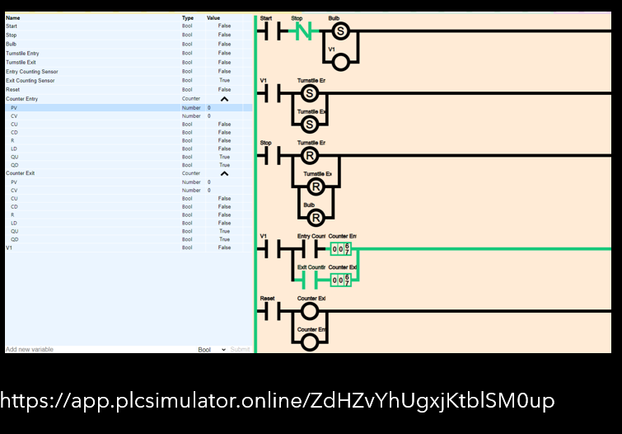

##### Problem 3

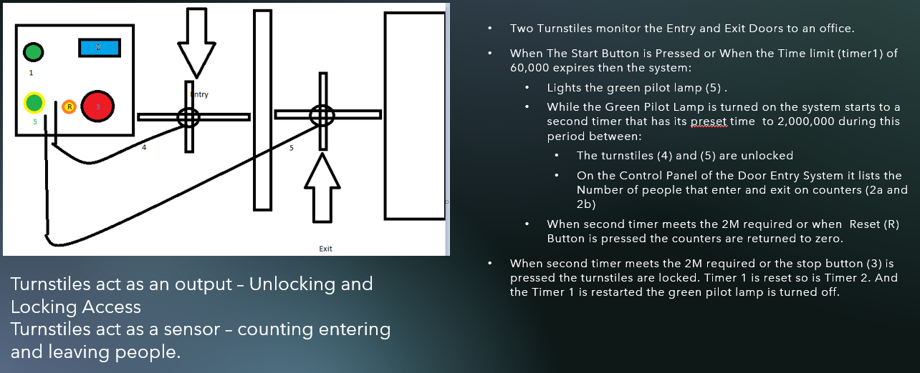

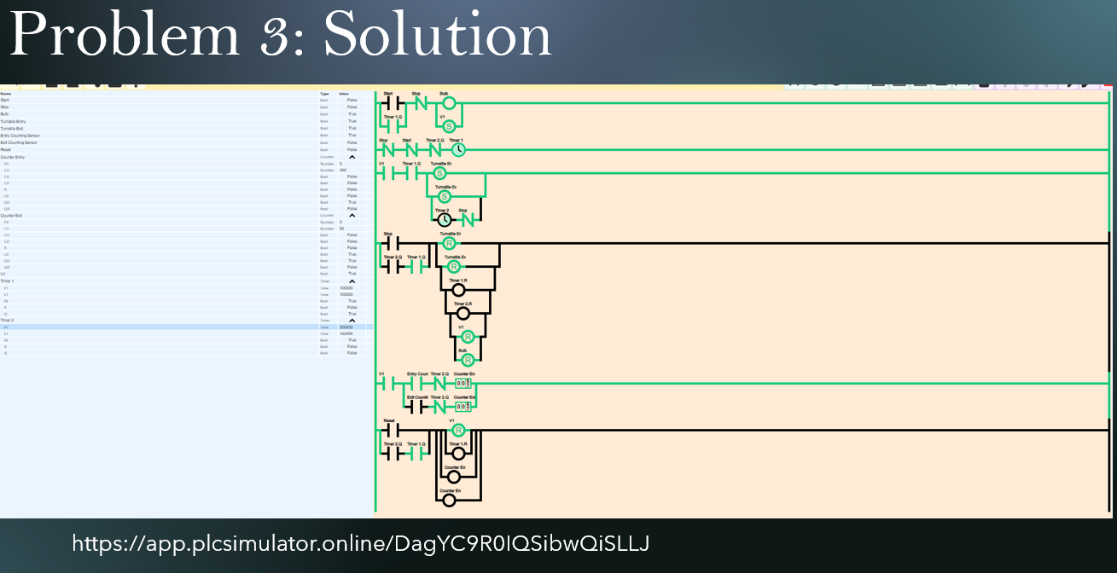

## Mathematical Functions



##### Mathematic Functions Commonly used in PLC’s

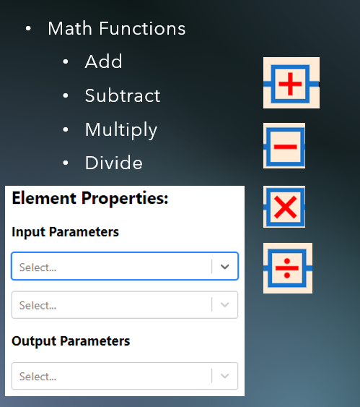

##### Math Functions on OpenPLC Editor

To access this operational block use the function block button 

Select Arithmetic

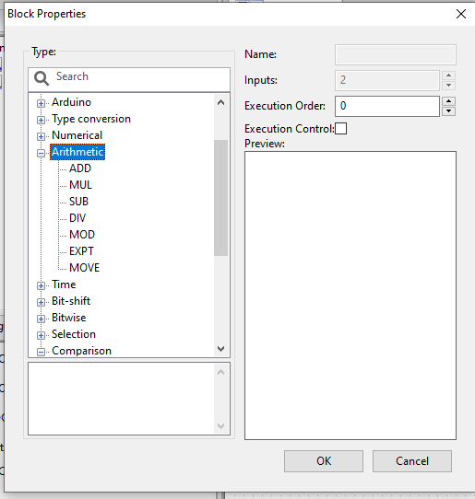

You can see the comparison blocks available there use them as you would logic input and output connections but this time you need to connect Variables that are integer containers or Integer Values only for the inputs while the outputs are also integer type containers. Please note floating point computations cannot be done directly here. Only Integer values as outputs or inputs are available.

#### Common Comparison Functions

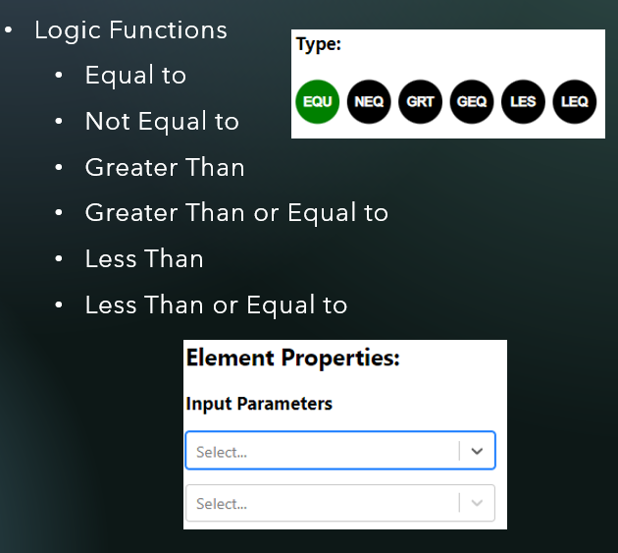

##### Comparison Functions on OpenPLC Editor

To access this operational block use the function block button 

Select Comparison

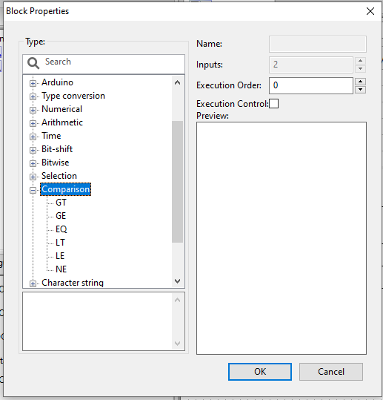

You can see the comparison blocks available there use them as you would logic input and output connections.

##### Notes on Using Math Functions



##### Problem 4

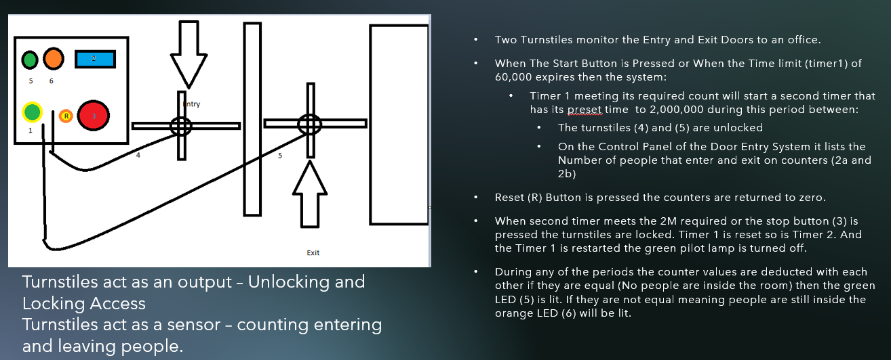

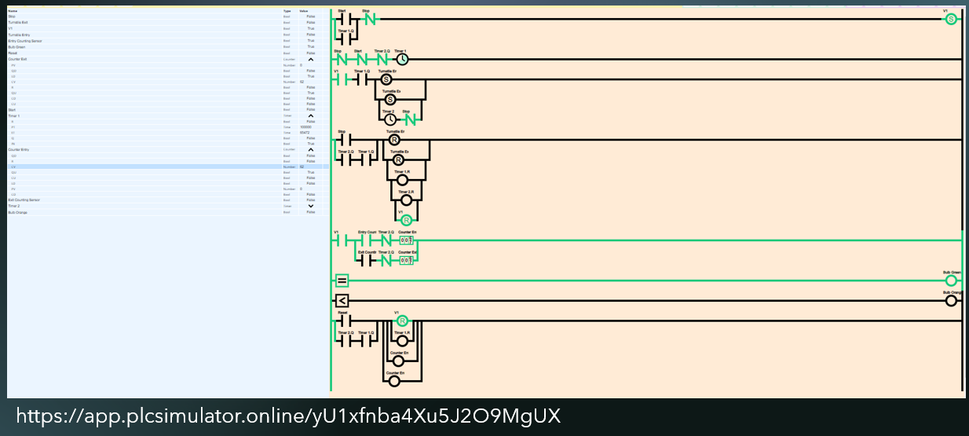

# MODBUS Basics

### History

Modbus is a transmission format system published in 1979 in Modicon® mainly intended for PLC.

Modus uses the format of one Master and multiple slaves up to 120 units

Data transmission is formatted into the following

Table . MODBUS Transmission Frame

|  |  |  |  |  |  |
| --- | --- | --- | --- | --- | --- |
| Start | Address | Function | Data | LRC | End |
| : | 2 Chars | 2 Chars | N Chars | 2 Chars | CR LF |

Address pertains to the following

Table . MODBUS Address Names and Types of Action

|  |  |  |  |
| --- | --- | --- | --- |
| Coil/Register Numbers | Data Addresses | Type | Table Name |
| 1-9999 | 0000 to 270E | Read-Write | Discrete Output Coils |
| 10001-19999 | 0000 to 270E | Read-Only | Discrete Input Contacts |
| 30001-39999 | 0000 to 270E | Read-Only | Analog Input Registers |
| 40001-49999 | 0000 to 270E | Read-Write | Analog Output Holding Registers |

Function Pertains to the following

Table . Function Codes in MODBUS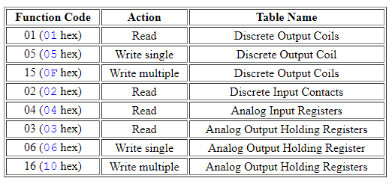

Longtidunal Redundancy Check (LRC) refers to an error checking mechanism.

For Full Systems this is not LRC but CRC of Cyclic Redundancy Check

To get a better understanding think of MODBUS as a communications and filing system. Each processor / controller in an Operational Technology Environment has memory and how that memory is arranged and can be accessed is something that falls in line with MODBUS.

Example in Omron PLCs the inputs are designated as 000.0 – 000.16 depending on the model of the PLC used convention can fall into an understanding that input pins actually fall into the category that this is accessible as Register Number 000 with bits 0 -16 being available for individual checking. The same goes for outputs designated as 100.0-100.16 in Omron PLC’s this refers to Register Address 100 with the individual bits being represented by the second number after the decimal point.

For this book we will use the following assignments

Please Note the Following Modbus addresses assigned to Physical Inputs on the Arduino Nano

Table . Holding Register Specifications

|  |  |  |  |  |
| --- | --- | --- | --- | --- |
| PLC MODBUS Address | Function | Pin | Purpose | New PLC Addressing Scheme |
| 10001 | Read Input Coils | D2 | Input | 1:0 |
| 10002 | Read Input Coils | D3 | Input | 1:1 |
| 10003 | Read Input Coils | D4 | Input | 1:2 |
| 10004 | Read Input Coils | D5 | Input | 1:3 |
| 10005 | Read Input Coils | D6 | Input | 1:4 |
| 00001 | Read / Write to Output Coils | D7 | Output | 0:0 |
| 00002 | Read / Write to Output Coils | D8 | Output | 0:1 |
| 00003 | Read / Write to Output Coils | D12 | Output | 0:2 |
| 00004 | Read / Write to Output Coils | D13 | Output | 0:3 |
| 30001 | Read Input Register | A0 | Analog In | 3:0 |
| 30002 | Read Input Register | A1 | Analog In | 3:1 |
| 30003 | Read Input Register | A2 | Analog In | 3:2 |
| 30004 | Read Input Register | A3 | Analog In | 3:3 |
| 30005 | Read Input Register | A5 | Analog In | 3:4 |
| 40001 | Read / Write to Holding Register | D9 | PWM OUTPUT | 4:0 |
| 40002 | Read / Write to Holding Register | D10 | PWM OUTPUT | 4:1 |
| 40003 | Read / Write to Holding Register | D11 | PWM OUTPUT | 4:2 |

In order to understand this better secure from the download link the tools needed to implement a MODBUS Slave and Master Simulation using MODSIM32 and MODSCAN32

### Virtual MODBUS Exercises:

1. Open the Virtual Serial Port

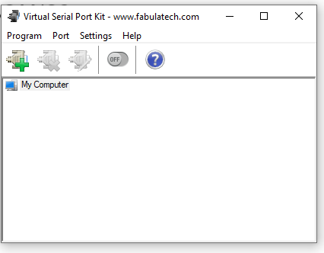

1. Click the Add Com Port Pair (+) icon
2. Use Serial Ports that are free (not overlapped)

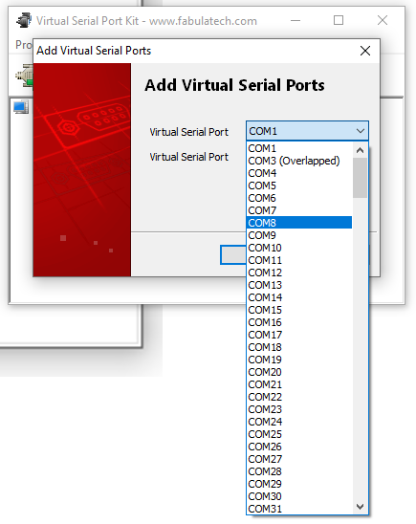

1. Do this for both ports and press OK to set the settings into record.

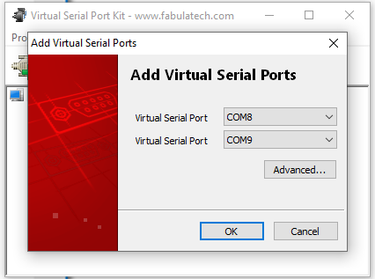

1. Click on the Enable Switch to activate the virtual port.

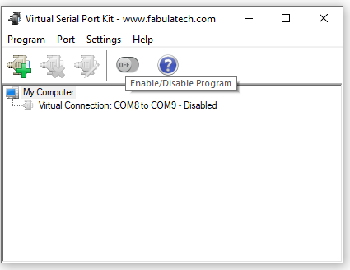

1. Turn on MODSIM32 and use one of the COMPORTS you enabled on the Virtual Serial port you can do this by

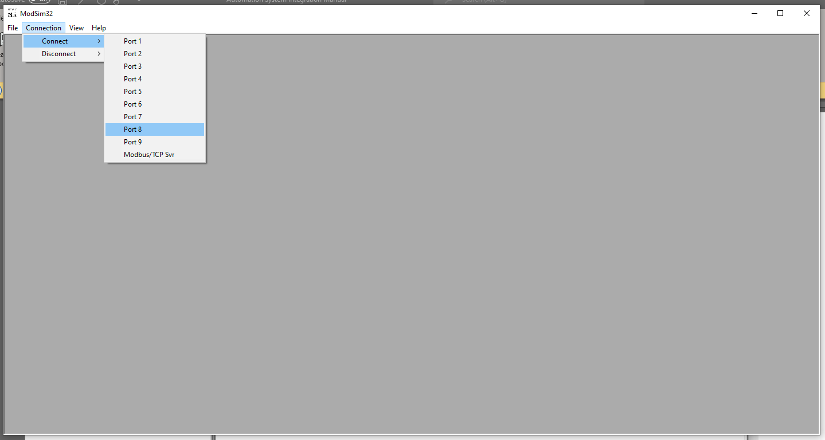

1. A pop up window will come out make sure to set the Baud Rates, Parity, LRC, Stop Bits and Data Size to the values shown below this step

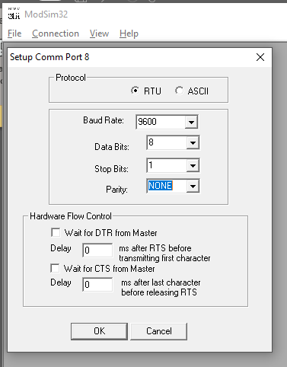

1. Create a new session using File -> New
2. Set up the values with the following values

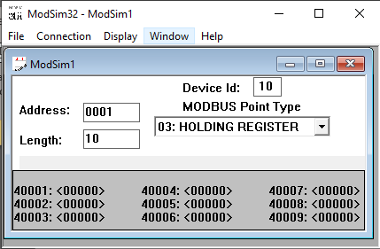

1. Open MODSCAN32
2. Setup a Session using File -> New
3. Make sure the values are set to the Values listed below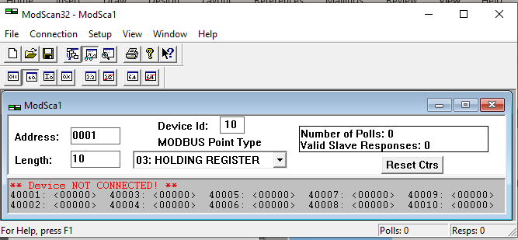
4. Click on the connection option on the menu bar set the parameter to those listed below

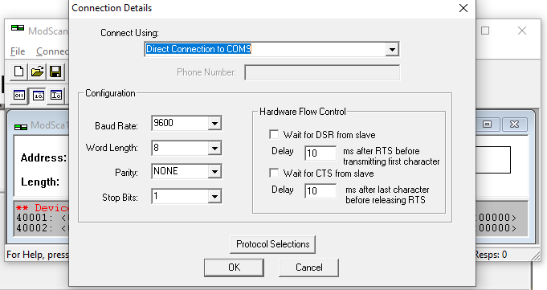

1. Arrange the Windows of the three applications to make it easy to see what is taking place between the three

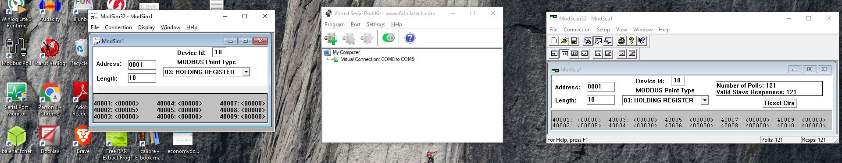

1. Click on 40001: <0000> a window popup should appear that shows how you can change the values on register 0001 with a function of 4 or read input register.
2. Type 3 and press Update Button.

### Explanation of Virtual MODBUS Exercise

MODBUS is a both a storage system of analogue data and digital I/O values. The virtual exercise shows the reader how changes on a single MODBUS Slave the MODSim32 application can cause this changes to the same registers inside the MODBUS Master played by MODScan32 application. The transmission is direct and if we can only see the memory registers we don’t really see that the master is requesting data from the slaves and slaves answering.

For the Virtual Exercise we selected the MODSIM32 to be Device 10 along Channel 1. Remember the MODBUS Master must communicate directly to the intended slave device by specify the correct Device ID. If you change the Device ID of the MODSCAN32 to you can see that its does to no reactions if you change the values. It even lists a MODBUS TimeOUT Error

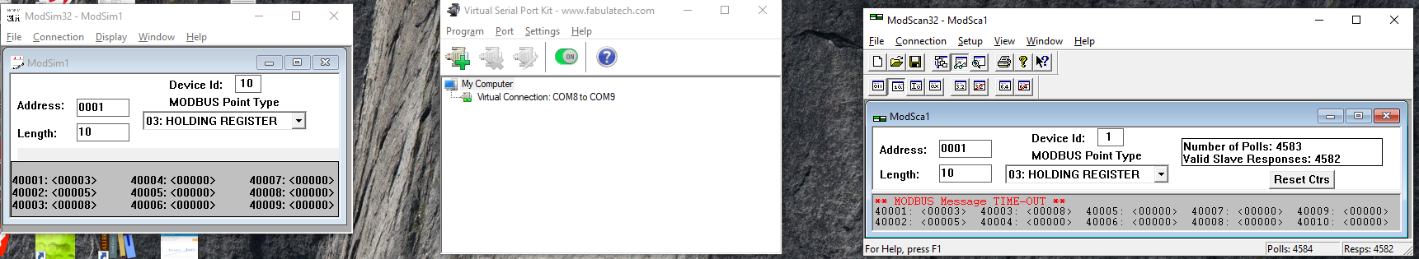

1. Watch as the value on 40001:<0000> on the ModScan changes to 3 as well.

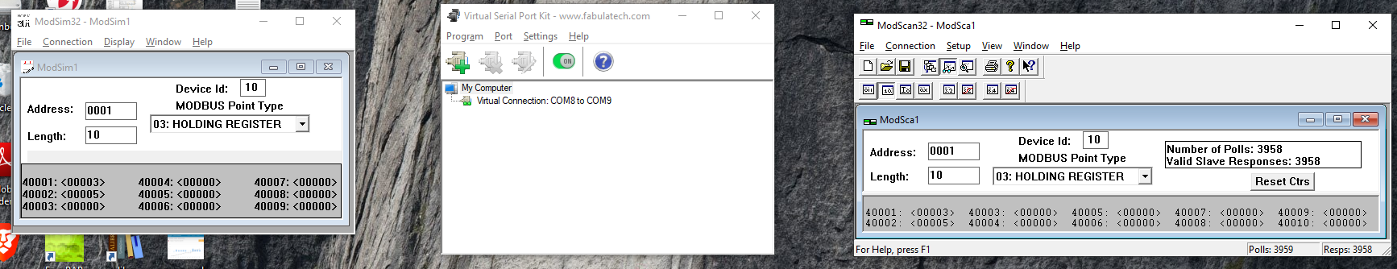

1. Try to do the same for the other holding registers.

## Activity 1. Modbus RTU Slave Implemented in Arduino using OpenPLC

1. Turn On your OpenPLC Editor Software
2. Encode the following details for your data structure

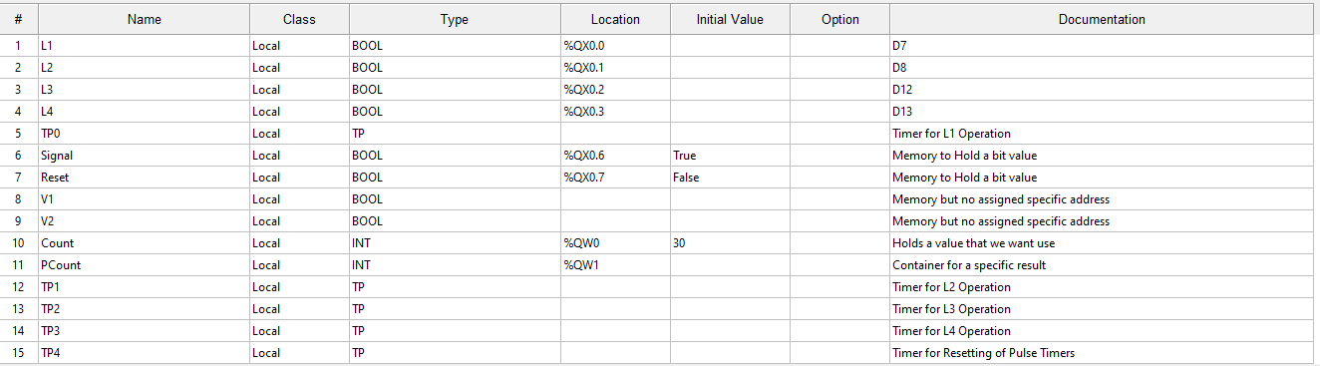

1. Encode this program using OpenPLC

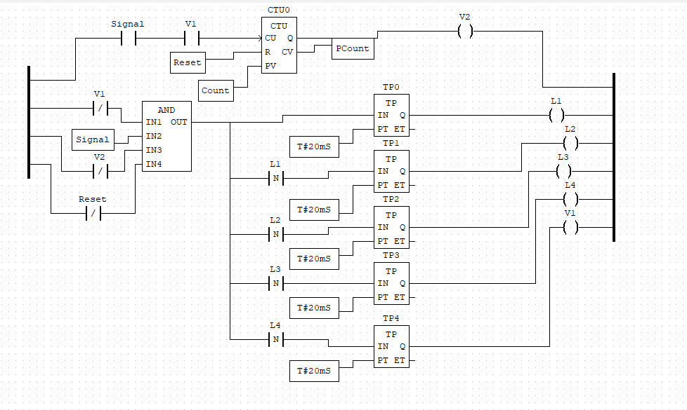

1. Press the Arduino Programming Button this should come up

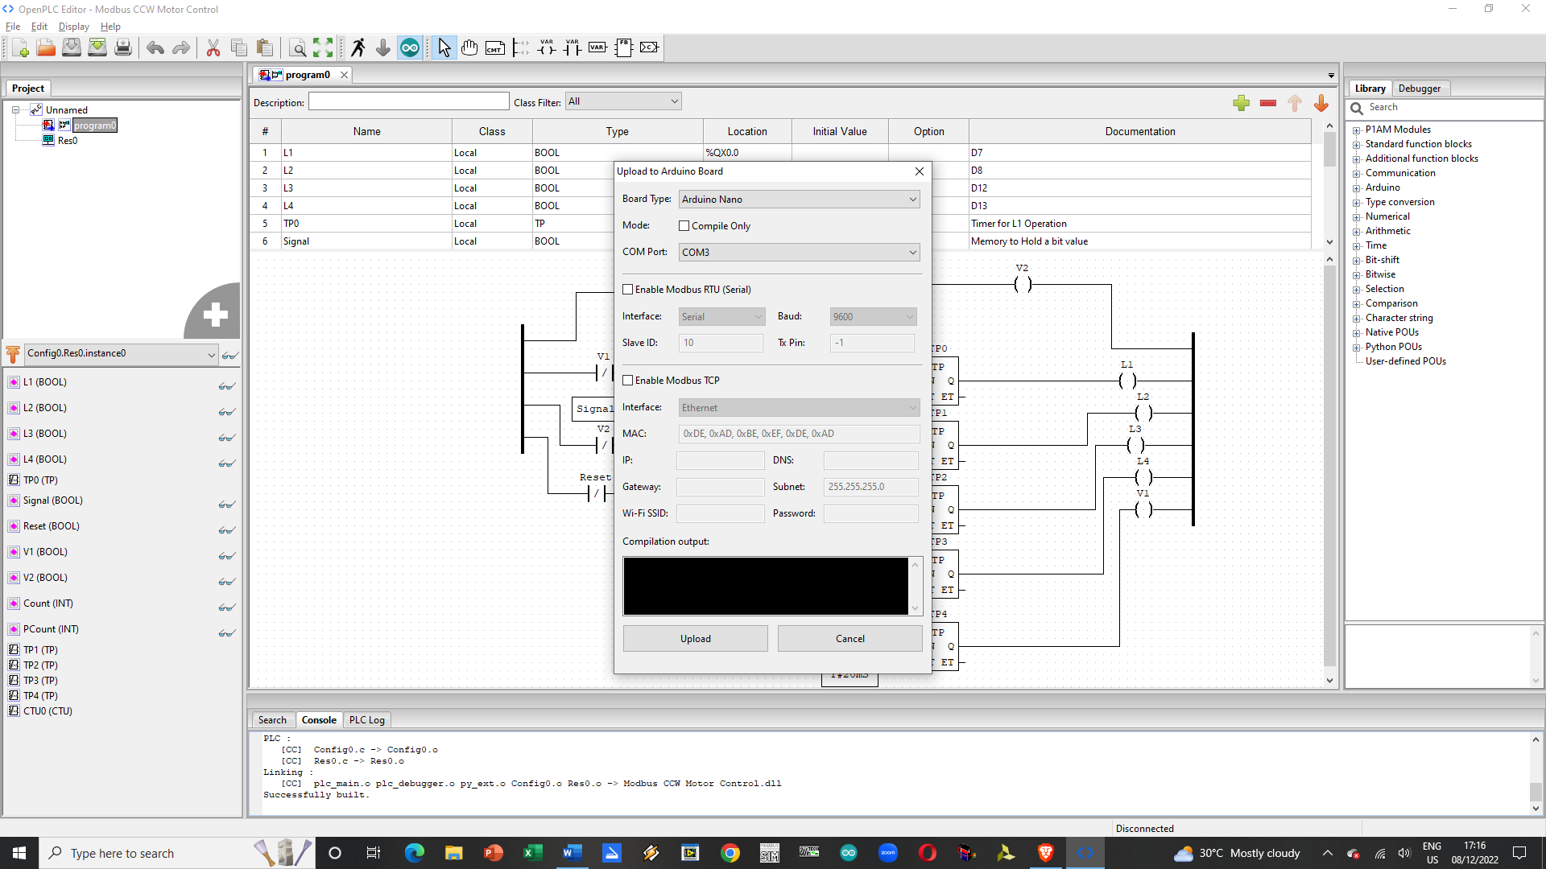

1. Place a check mark on the Enable ModbusRTU Serial.
2. The Options of Interface Type, Baud, Slave ID and Tx Pin should be made accessible.

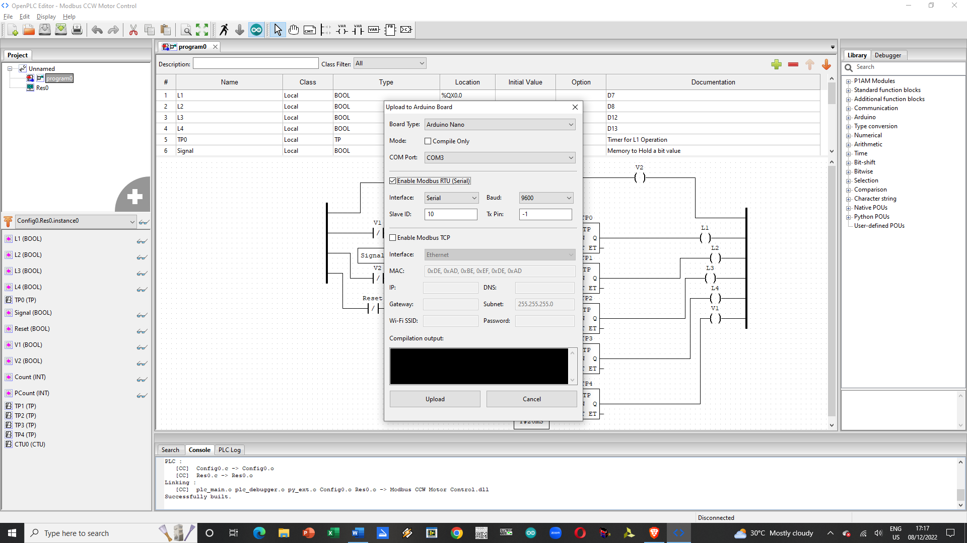

1. Set the Interface to Serial
2. Set the Baud to 9600
3. Set the Device ID to 10.
4. Maintain that Tx Pin is -1
5. Press Upload and load the data into the device thru the programming channel.
6. Turn on ModScan32. ModScan32 has a default Address of 0 making it the Modbus Master while your device is a slave device (Address between 1-120)
7. Setup your ModScan32 to have all four function types with the same addresses as shown in the figure below:

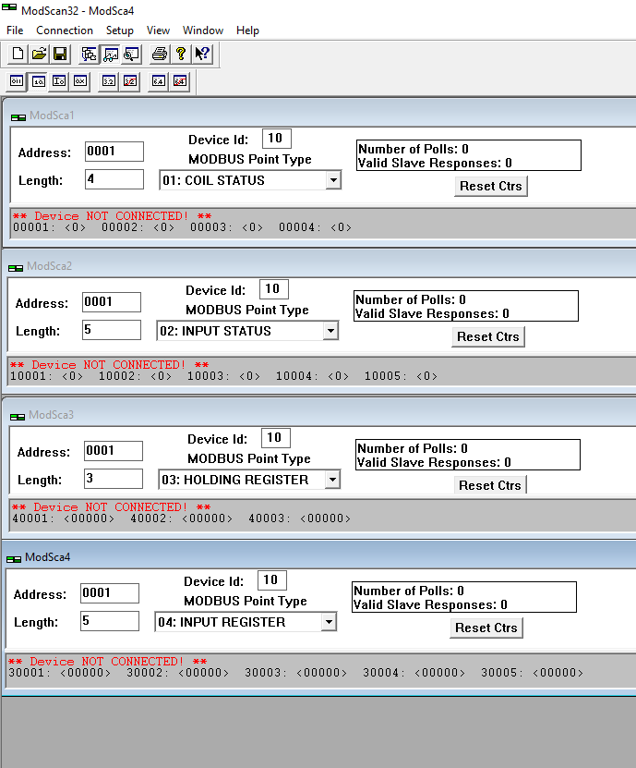

1. Press [Alt] -> Connection

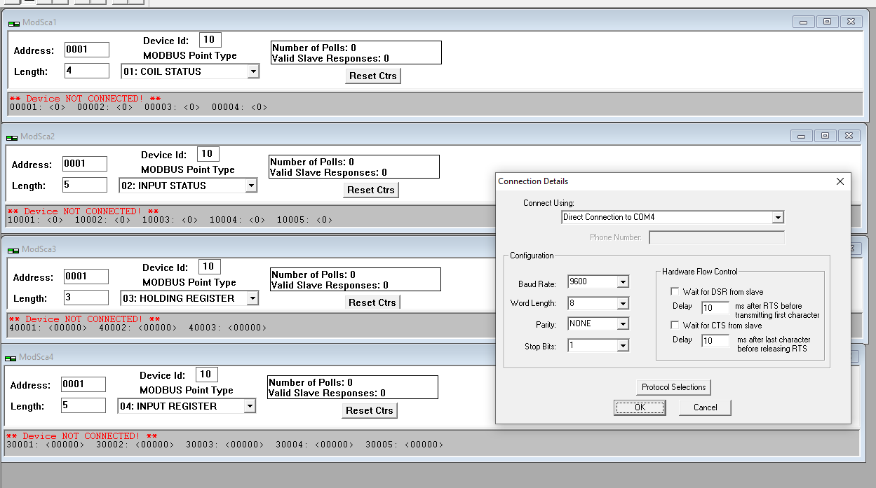

1. Select the Serial Port your Arduino can be seen at in my case its COM4 this is the same as the programming port you used in the PLC Editor.
2. Press OK to connect to your controller.
3. Initially all the four functions will register Device Not Connected Wait for the processor to finish its operations to make a handshake with the master once it does the Device not connected message will disappear.

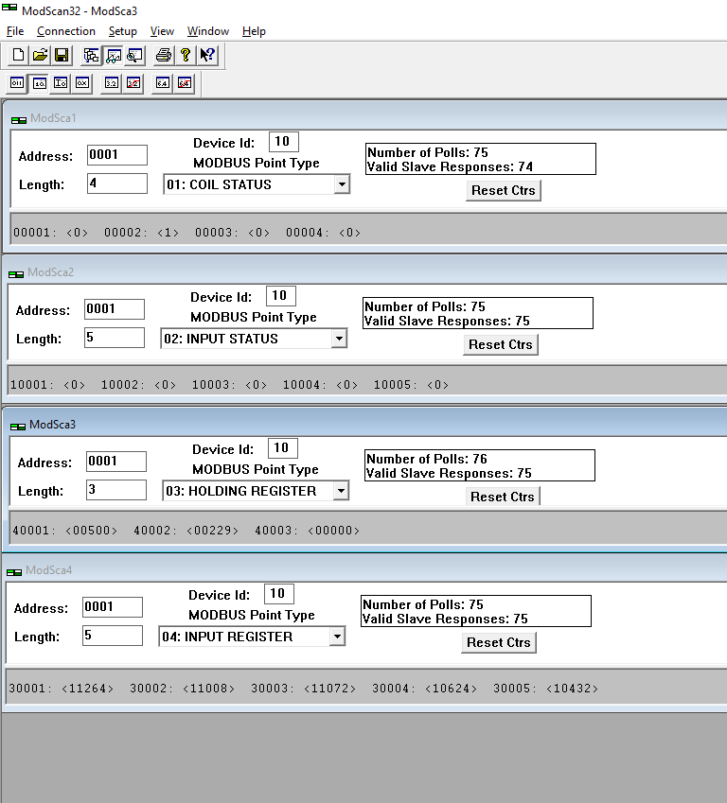

1. You will notice in Function 4 we have values listed that will change this is due to the analog to digital converter polling all 5 pins and sending the data to the address 30001-30005.
2. Press the required buttons you will see this will change the Input status 10001 - 10006 data from their current value to another different one.
3. When the controller changes the output signals it will show up on the coil status area 0001-0004

## Activity 2. Making use of the Input Registers

1. Stop the ModScan32 by Terminating the Connection (Disconnect)
2. Open a new plc program
3. Create a the necessary data memory tags as shown below

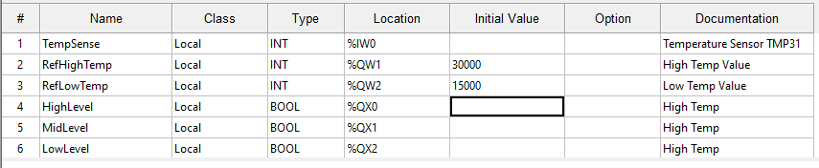

1. Create the Program shown below

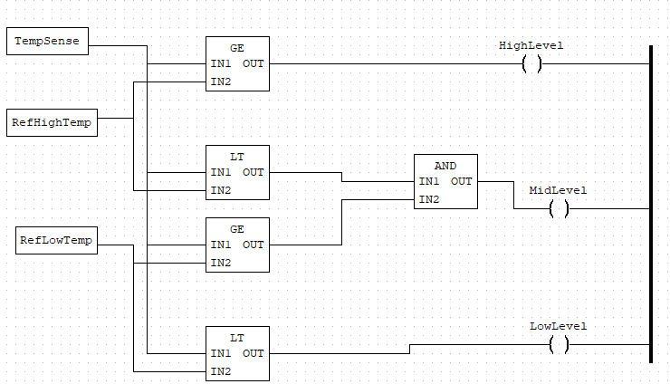

1. Upload the Program to the Logic Controller
2. Turn on ModScan32 by using the Connect Option

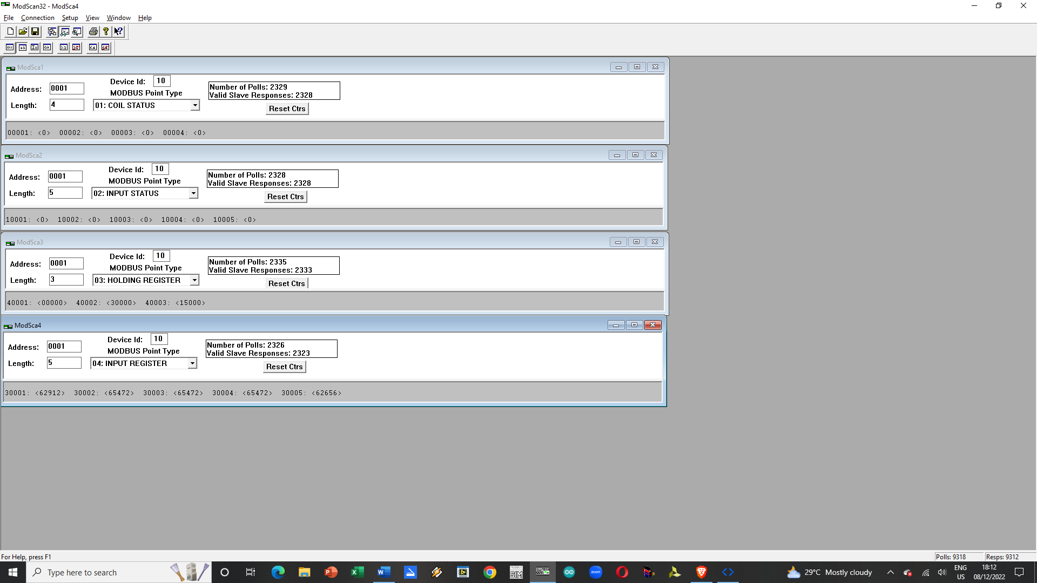

1. Observe the value on the 30001 in relation to 40002 and 40003 they should react appropriately to the values on D7, D8 and D12 (00001, 00002 and 00003 respectively)

# Human Machine Interface

Human Machine Interfaces or HMI’s for short are just graphical presentations of a process / monitoring screen to show that a current device status is and what it is doing or has done. These devices are created to allow visualization of the process from a remote location from where the process is located at or to understand what is happening to a machine that is currently active.

HMI’s created for industrial applications typically use MODBUS as their Network and Data Link layer while the physical is handled by either RS232 or USB or RS485 or IEEE 802.1 depending on what you want to use as your transmission system. For this book we shall just use USB as our Physical Layer this is very similar to RS232 Transmission systems.

The beauty of having to create and field an HMI is that your process monitor will not need any added training to oversee a process he/she simply interacts with the HMI to force a system to adjust its settings or to see its current status.

## Rules on Creating HMI

Before you start with any HMI Creation work make sure to figure out and state what the parameters you want to see, manipulate and how you want to see these parameters.

The appearance can be any of the following ones from Advanced HMI

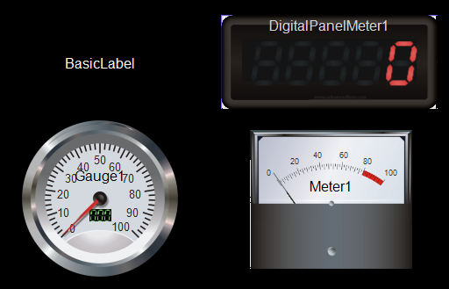

These best to use for Analog Values but for discrete inputs and outputs LED type indicators are best us to use but our implementation of MODBUS uses Holding (4) and Input (3) Registers not discrete holding coils (0) or input coils (1) so we are mostly stuck with these type of indicators unless you assign one Modbus RTU Register to each one of your output and input pins.

For this you may use the table below:

Table .Planning your HMI layout based on table 5.

|  |  |  |  |  |
| --- | --- | --- | --- | --- |
| PLC MODBUS Address | Use of Register | Read Only | Write – Read | Desired Appearance |
| 40001 | Input Pins State | X |  | Digital Panel Meter |
| 40002 | Output Pins Trigger |  | X | None at this time (Not Implemented) |
| 40003 | Output Pins State | X |  | Digital Panel Meter |
| 40004 | Analog A0 Value | X |  | Meter Type |
| 40005 | Analog A3 Value | X |  | Gauge Type |
| 40006 | Inputs Trigger |  | x | None at this time (Not Implemented) |

## Advanced HMI steps on how to use it

1. Download the Advanced HMI solution from their website advancedhmi.com
2. Install Visual Studio 2022 Community on your PC.
3. Unpack AdvancedHMI and open the sln file.

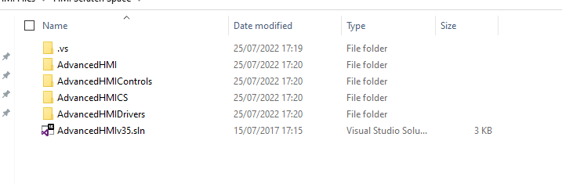

1. This will load the file into visual Basic.
2. You will be greeted by the screen shown below

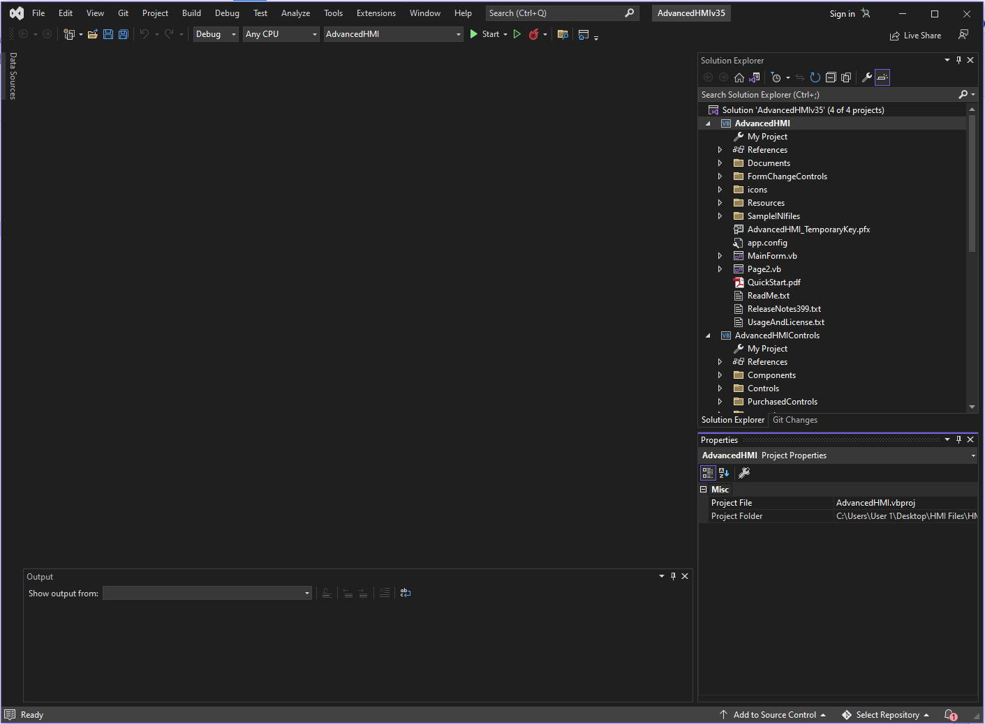

1. You need to build the solution first do this by using Build🡪 Build Solution

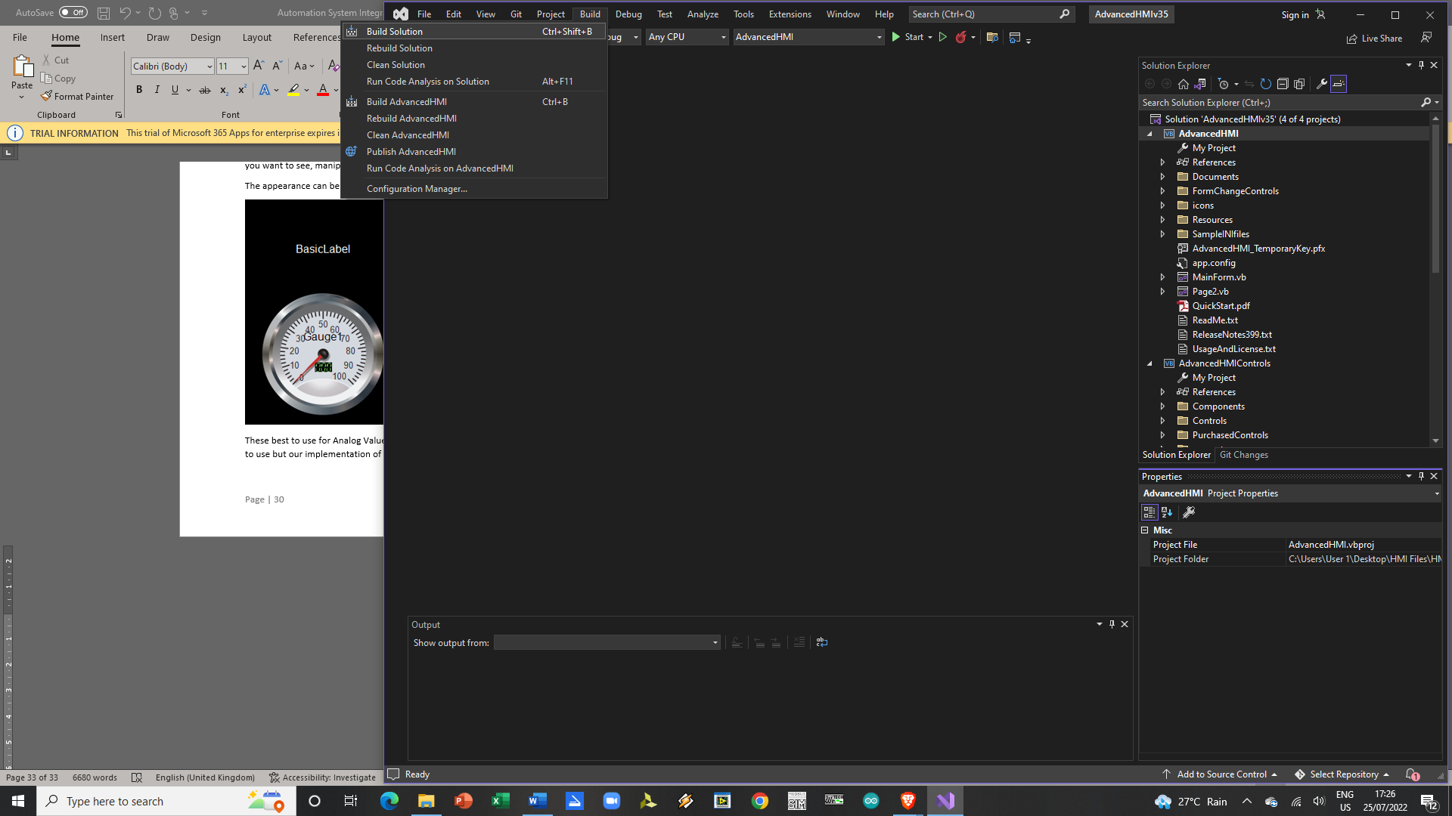

1. Once built you can launch your GUI Screen Builder by going inside the Solution Explorer and into the Advanced HMI Solution locating and clicking on the file MainForm.vb
2. Now once the project is built use View🡪 Toolbox to show your toolboxes

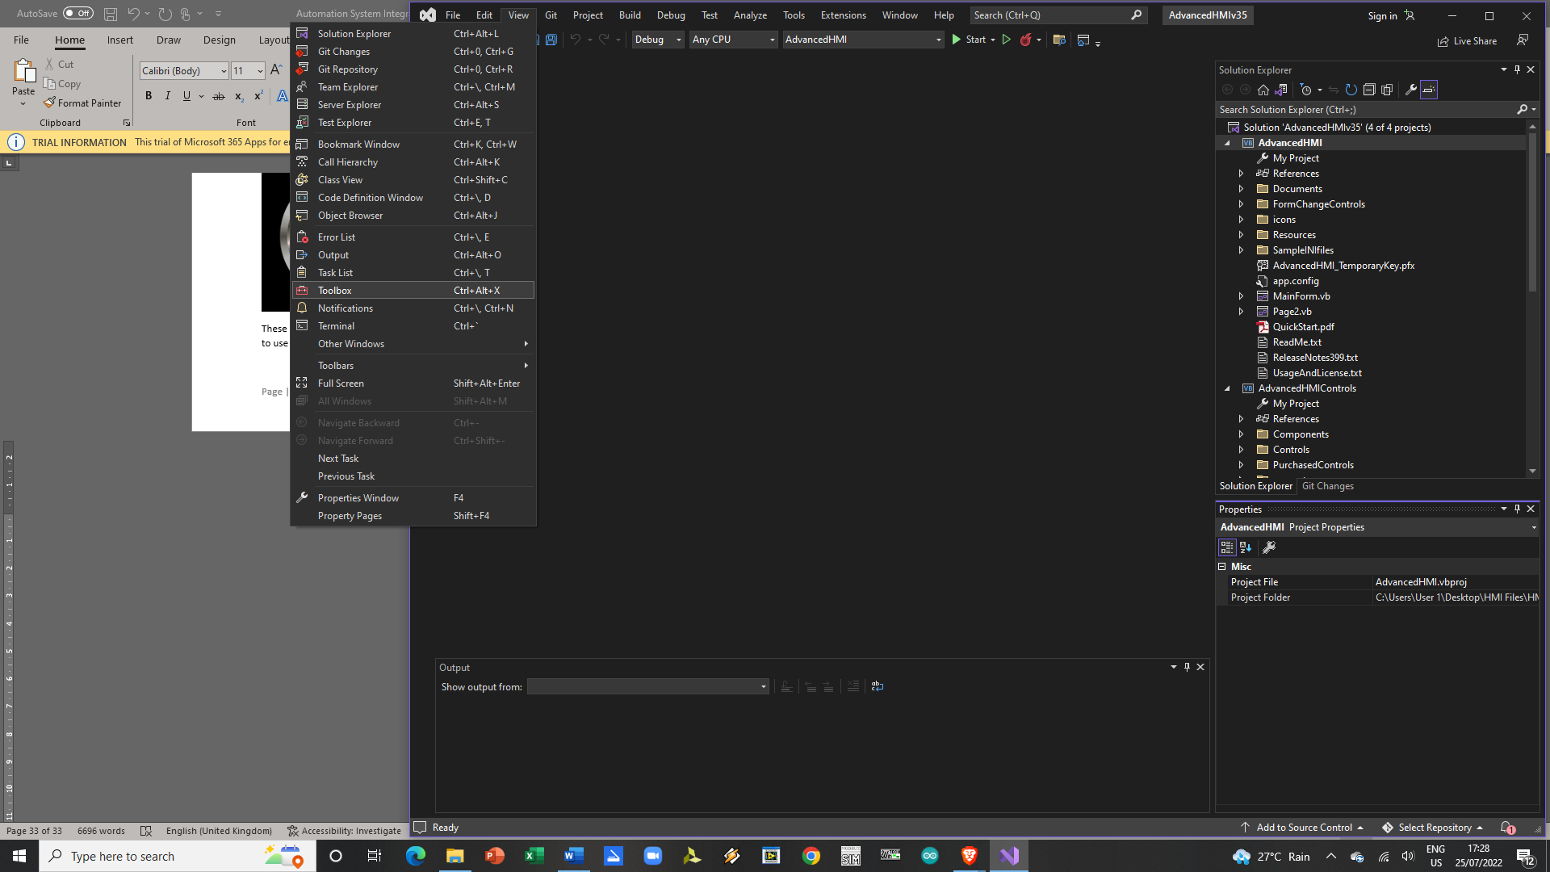

1. On the AdvancedHMI Drivers Components section of the tool box click on MODBUS RTU. Select Drag and pull it into the Layout screen area.

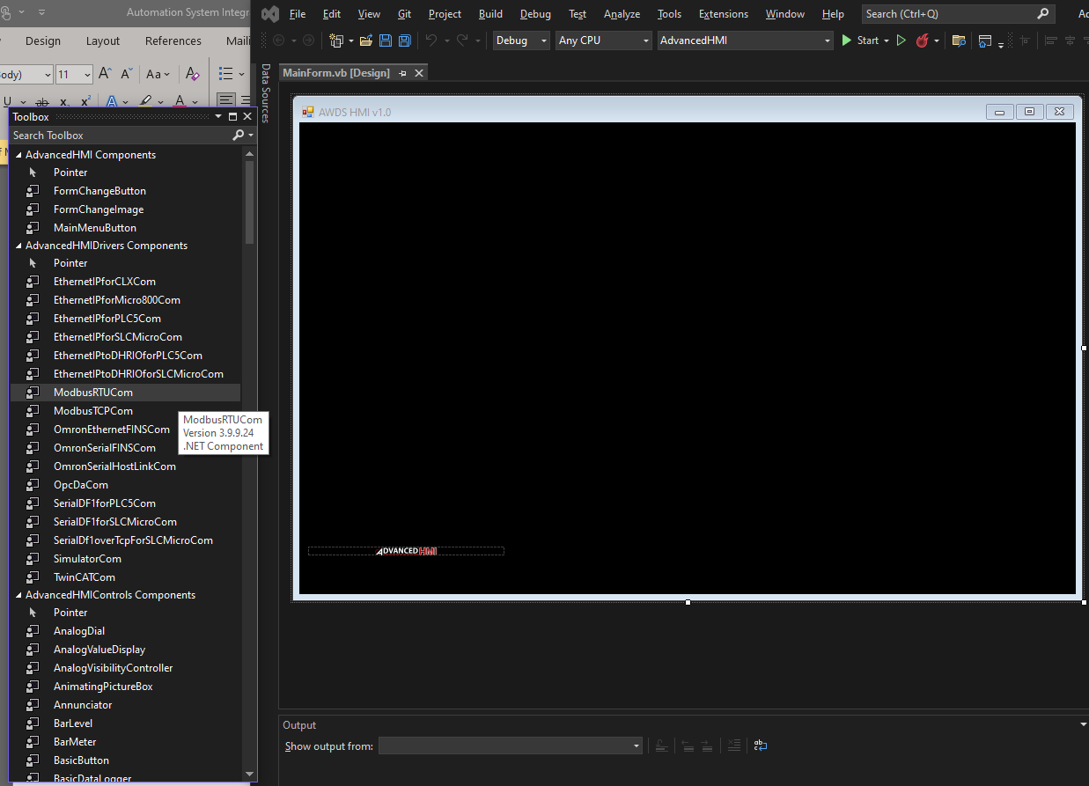

1. Once its active in the GUI Area you should see at the bottom left of the gui screen the words MODBUSRTUCOM1.

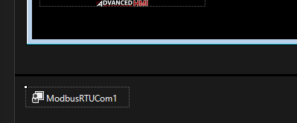

1. Click on this and on the bottom right area of your Visual Studio Workscreen a properties window should open.

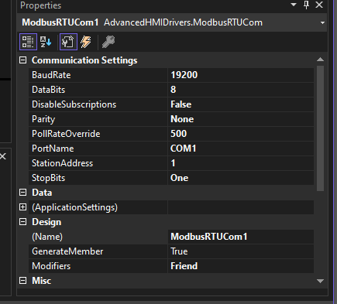

1. Change the Station address to match your Baud rates, Slave ID of choice and the COMPORT to one that you intend your hardware to or your MODSIM32 to using Visual Serial Port.
2. On the Toolbox go to the AdvanceHMIControls Components and browse thru the title names until you find the one listed in Table 6.
3. Click, Drag and Drop it into the GUI Work Screen area 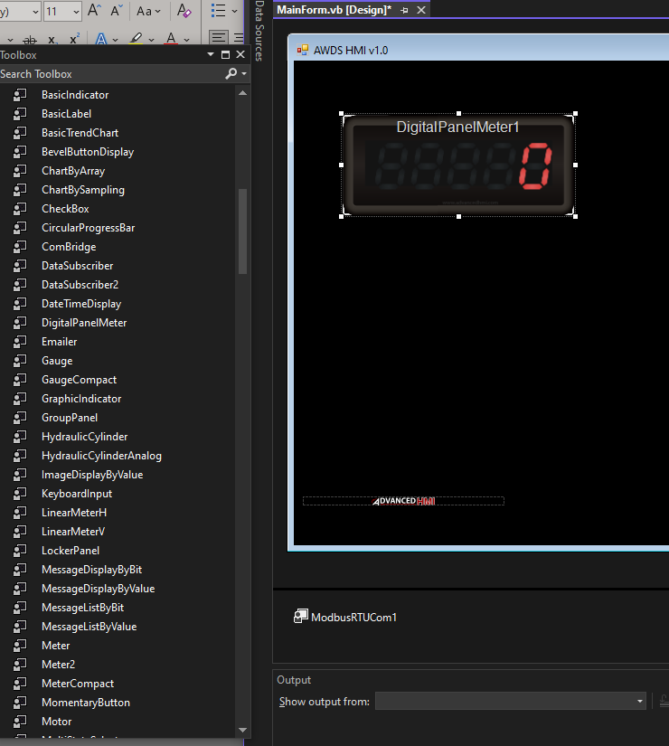
4. Do the same for the other required items until you end up with this layout

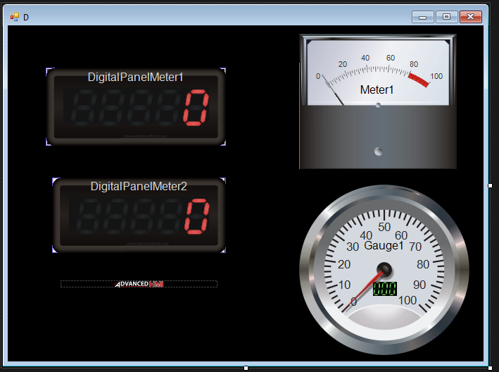

1. Click on the first digital meter and change the name of the panel meter to your desired common name of the value written inside it. Use Table 6 for this requirement.

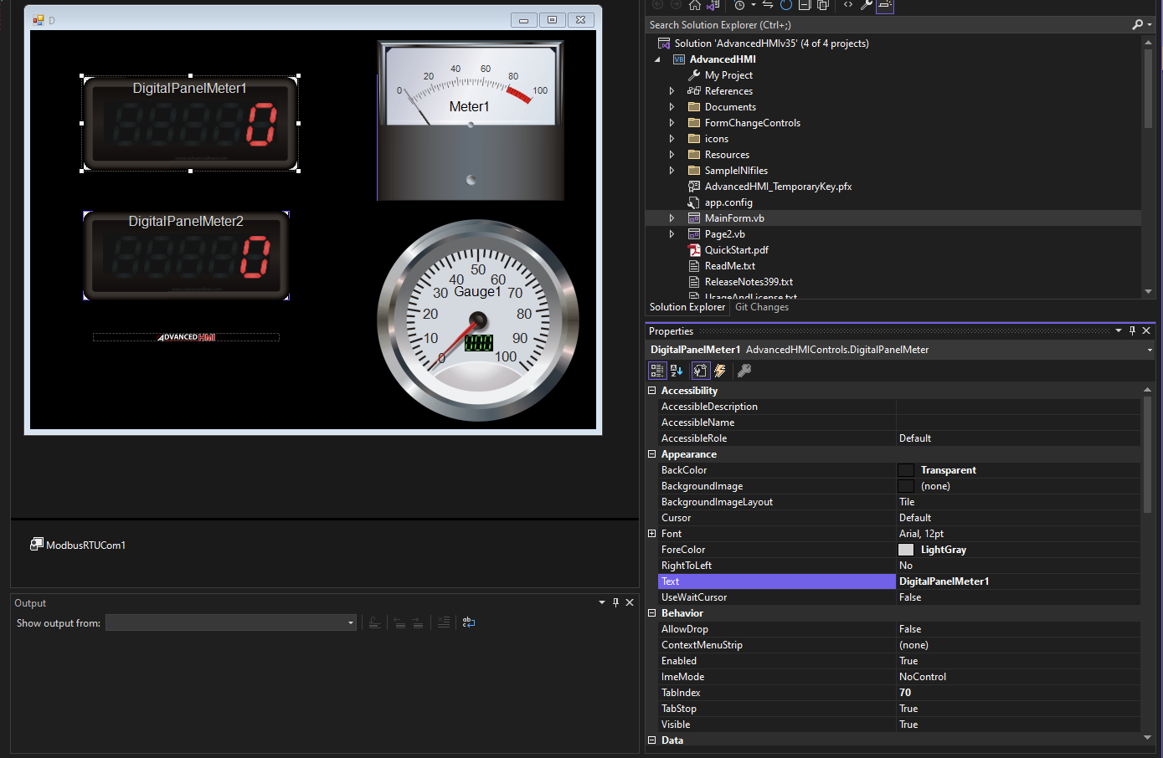

1. Do the same for the second digital meter

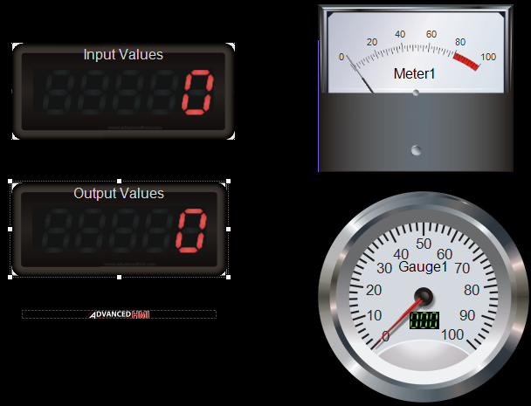

1. Click back to the Input Values Digital Meter Face and on the properties area scroll down to its bottom where you can find PLCAddressValue entry box

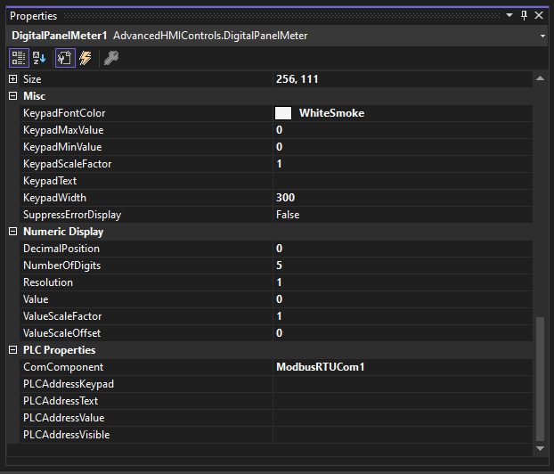

1. Use Table 6 to type in the register used for this which is 40001.
2. Do the same for the Output Values and Meters 1 and Gauge 1 assigning them to 40003, 40004 and 40005.
3. Click on Meter 1. Change its name to A0
4. On the properties tab scroll down to Misc Label and change the maximum value to 1024 and the minimum to 0.
5. This will change the meter face to this

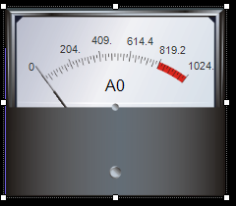

1. Do the same for gauge 1 instead change its name to A3 and its maximum value to 1024 too.

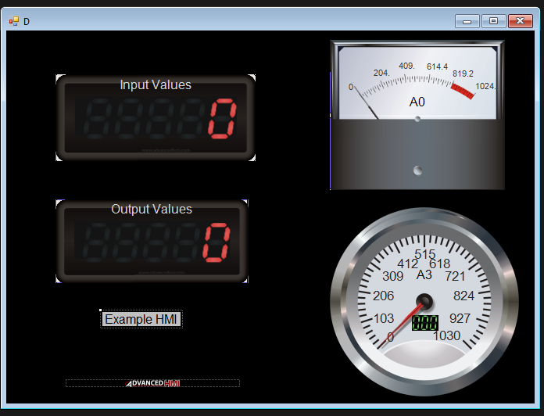

1. When you reach this point you are ready to test your HMI solution.

## Software Bench Testing your HMI

This section contains steps that are needed to evaluate your HMI before you connect it to the Arduino.

1. Open the Virtual Serial Port



1. Click the Add Com Port Pair (+) icon
2. Use Serial Ports that are free (not overlapped)



1. Do this for both ports and press OK to set the settings into record.



1. Click on the Enable Switch to activate the virtual port.

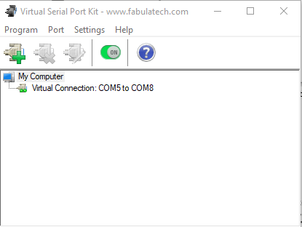

1. Turn on MODSIM32 and use one of the COMPORTS you enabled on the Virtual Serial port you can do this by



1. A pop up window will come out make sure to set the Baud Rates, Parity, LRC, Stop Bits and Data Size to the values shown below this step



1. Create a new session using File -> New
2. Set it up for the Session ID to be 10; Type - Holding Registers and Number of Registers 16. Starting Address is 0001
3. Make sure to adjust the HMI Modbus RTU to COM5 and Station 10 and 9600 Baud Rate.

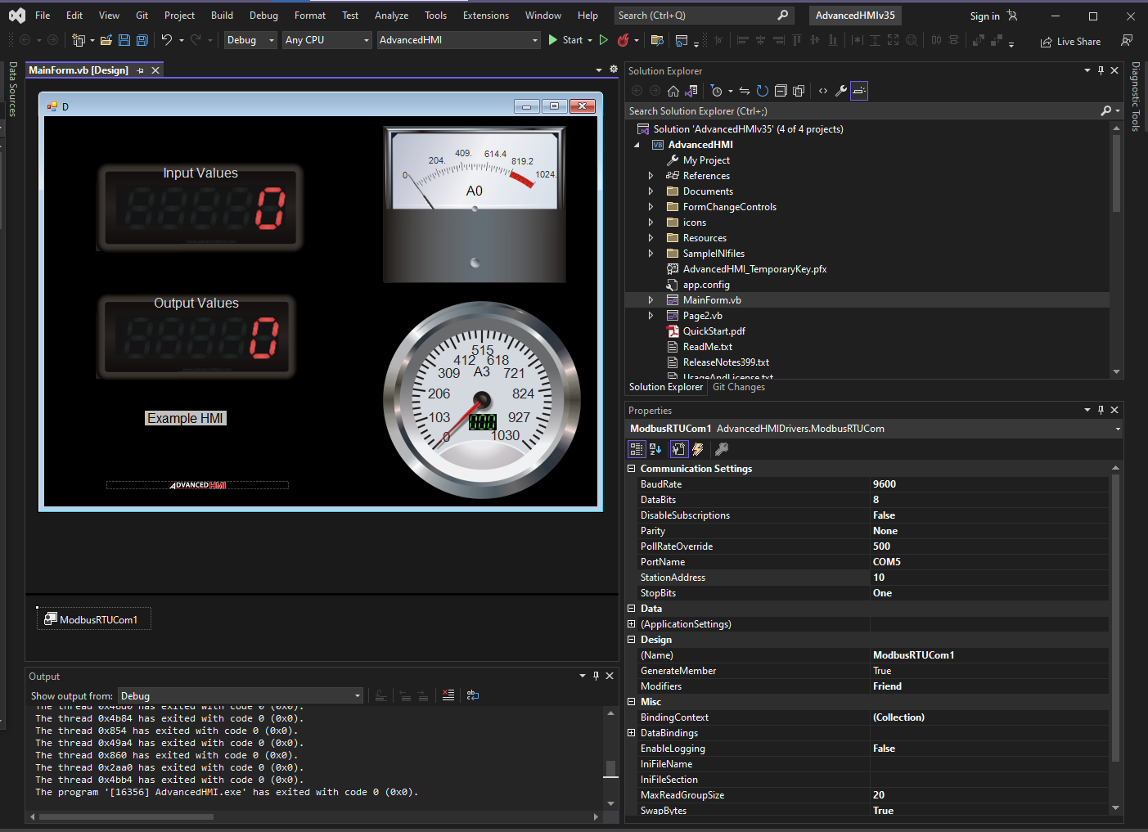

1. Once set press the start button to run the solution and test the codes. You setup should be consisting of the HMI, Virtual Serial Port and Modbus SIM32

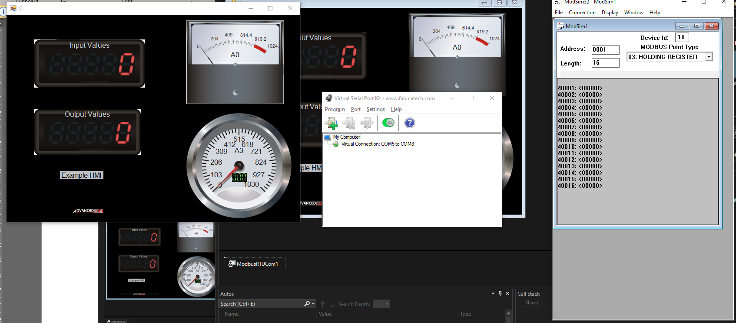

1. Change the value on 40001 to 25 you should see it change on Input Values
2. Change the value of 40003 to 8 you should see it change on the Output Value
3. Change the value of 40004 to 213 you should see A0 needle move to the right
4. Change the value of 40005 to 500 you should see the A3 Gauge move the center

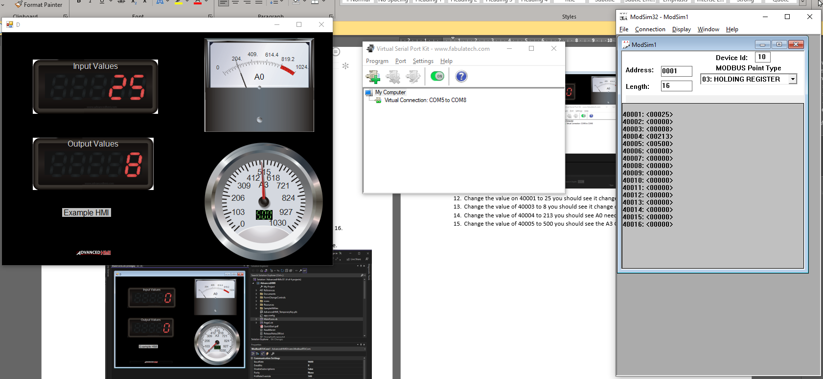

1. Disconnect your ModSim32 using Connection 🡪 Disconnect 🡪 Port 8
2. Turn off your Virtual Serial Port
3. At this point your HMI is working and can be connected to the Arduino

# Migrating your Work from AdvancedHMI Solutions Workarea to an executable

This is a simple task:

1. Go to the folder that contains the advancedHMI.sln file you used to launch the application.
2. Select the AdvancedHMI folder
3. Inside the folder you will see another set of folders select and go into the bin folder
4. Inside the bin folder select the Debug Folder you should see your solution file in .exe form there.
5. Note that this executable form is soft coded to the Comport you set the Modbus RTU at so be careful to make sure that your device is detected on that computer thru this comport. Otherwise you may need a virtual serial port kit software to the link the hardware port to the incorrect connection of the HMI.

# Activity 1D: Connecting your AWDS Modbus, EEPROM, LCD to the HMI.

1. Prepare an HMI for your Modbus AWDS. Use the Advanced HMI steps and how to use it instructions to make your own layout.
2. Test it using a Modbus Simulator first before testing it on your device.

# Using Winlog Lite 3.0

The application we developed in the previous section used Visual Studio and Advanced HMI. Understanding how to use the solution package based on Visual Studio is a good starting point for HMI development but it only exposes you the learner to only one type of software. So now I want to introduce the commercial software called Winlog in this case its lite edition. This was a recommended software by my instructor since its PC based but the end product if you have the pro edition can be ported to a java applications. You may download this software thru

<https://www.sielcosistemi.com/en/download/public/winlog_lite.html#:~:text=Winlog%20Lite%20is%20the%20free,60%20minutes%20of%20full%20operation>.

## Preparation for Use and Opening the Program

Sielco Sistemi emailed me that Winlog Lite 3.0 as this July 2022 is now not covered by a paid edition which is a shame instead they sell the Winlog Pro edition. This program (Winlog Lite) needs to be installed. After installation you can find it on the W section of the applications menu area.

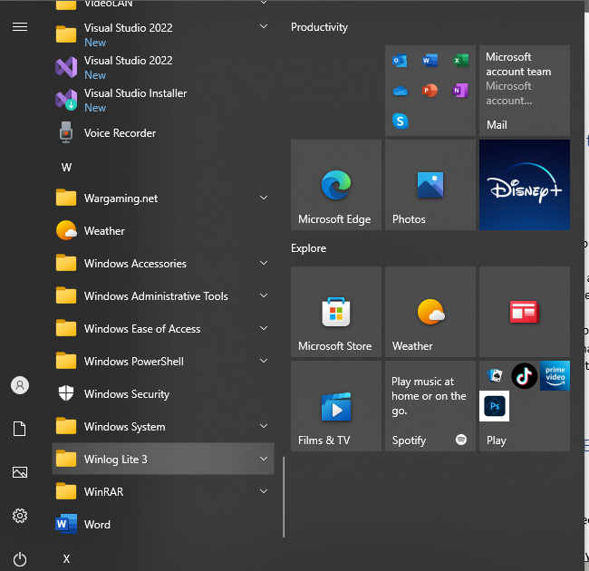

Click on the Winlog Lite 3 folder and find and click on the Project Manager Application



This will open up a new window that looks like

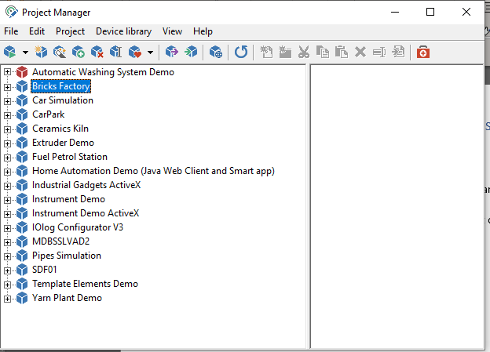

To create a new file click on the box icon with the sun.



This should lead to a new project being declared.



You can rename this to your liking.

Expand the project to show its contents

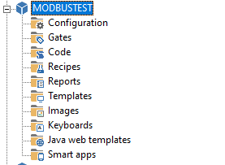

Click on the configuration folder it should show you the following

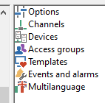

## Setting up Modbus communication

Double Click on the Channels. It should open up a new popup window

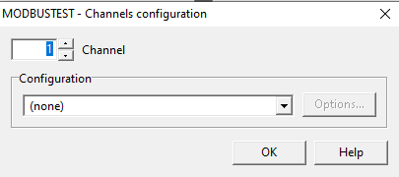

Click on the configuration, find MODBUS RTU and select it from the menu

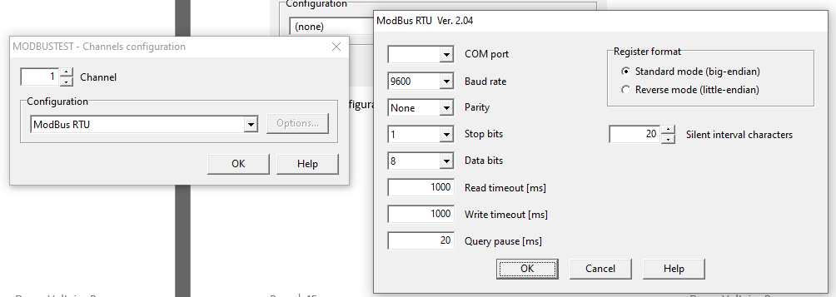

Set the COMPORT, Parity, Stop Bits and Data Bits

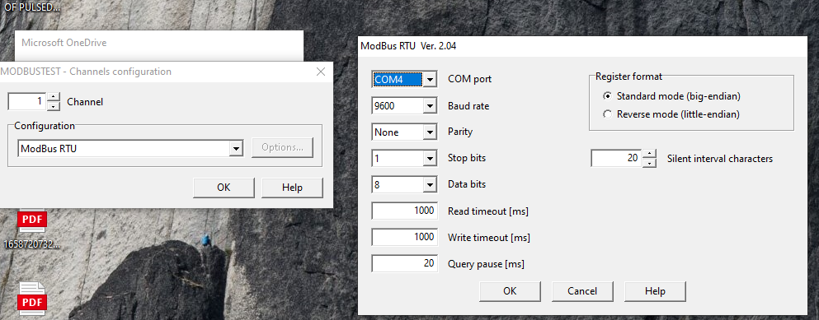

Press OK on the MODBUS RTU Configuration Pop – up

Press OK on the Channels Configuration this will bring you back to the Project Manager Window

Proceed to double click on the device.

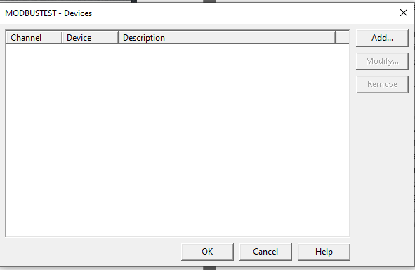

Click on the Add Button and set your Slave Device ID here

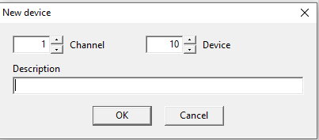

You can be able to verify the configuration settings will be shown to you after you confirm the new device.

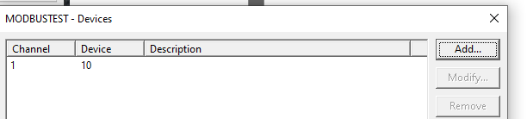

Press OK here this brings you back to the project manager.

Proceed to click on the Gates folder inside the project your editing.



This will show you the following data types

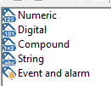

Gates are also known as tags in other general language used in PLC

At this point open up your program or au16data table to know what is the nature of the inputs for this example its actually

Table . au16data Containers

|  |  |  |  |  |  |  |  |  |
| --- | --- | --- | --- | --- | --- | --- | --- | --- |
| 0 | 1 | 2 | 3 | 4 | 5 | 6 | 7 | 8 |
| Prime | Command | Value | referencetime | count | Elapsed time |  | Motor On / Off | SML  Value |

Click on the Numeric this should open up the Gate Builder Screen

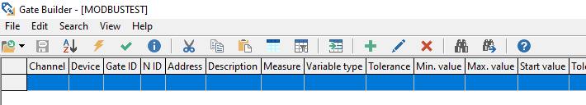

Press the green plus sign to open listing of new tags.

Use your version of Table 7 to create the table.

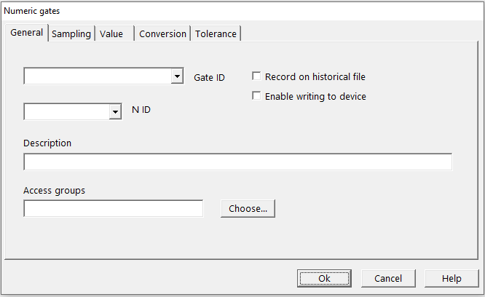

Add in the Gate ID this is a text value at assigns a more easier to remember name for the type of data.

Add in the N ID which is just a number that denotes number in a series of similar numerical tags there are you should start at 1.

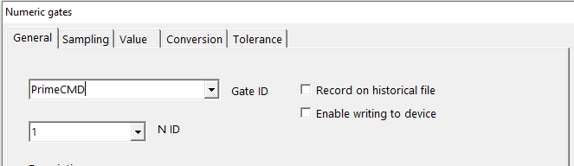

Click on the Sampling Tab these open configuration items should be shown.

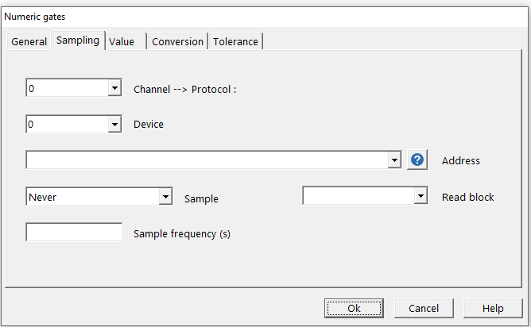

Select Channel you configured previously

Select the device ID number of your Arduino.

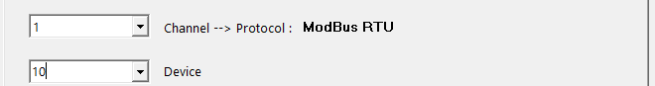

You will notice upon selecting 1 Ch the name of the protocol is shown associated with this channel.

The address is bound by a prefix number system table 8 shows it.

Table . Address Prefixes for Numerical Input and Holding Register

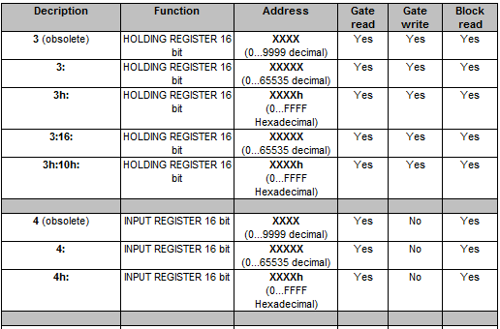

Type in 4: and followed by the address using table 7 add one to this since Winlog lite is base 1 software configuration not like Arduino which is base 0.

Let the program sample the register with the setting Always

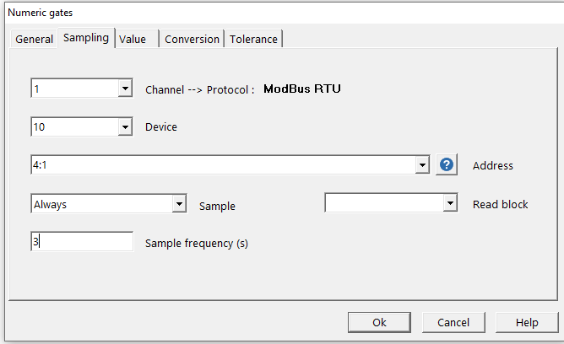

The sample frequency is up to you to determine and press ok

Populate the Gate Builder with more numeric tags based on Table 7.

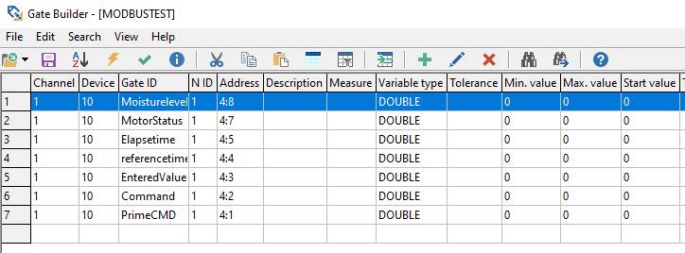

Now we need to edit some values like the Maximum Values

Double Click the tag you want to edit

Click on the value tab

Write the minimum and maximum data values

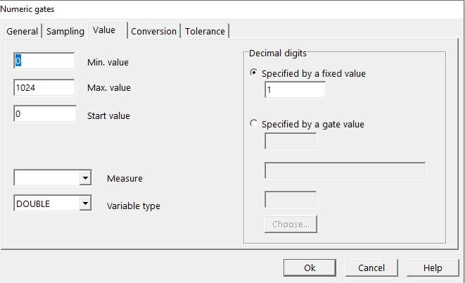

Click on the Conversion Tab. Use this feature if you want to map out values using the raw data that your machine provides.

For the Soil Moisture Meter this is

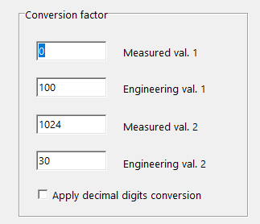

This once you edited all of the values you should end up with something like this.

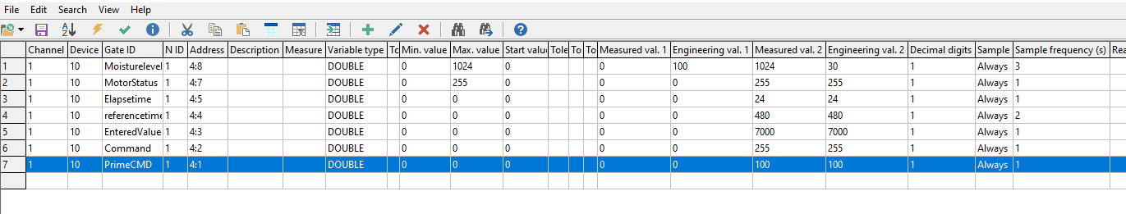

Press the Save Button [ Diskette Icon]

Leave the Gate Builder Window.

Test your interface first by running the software using the Run command.

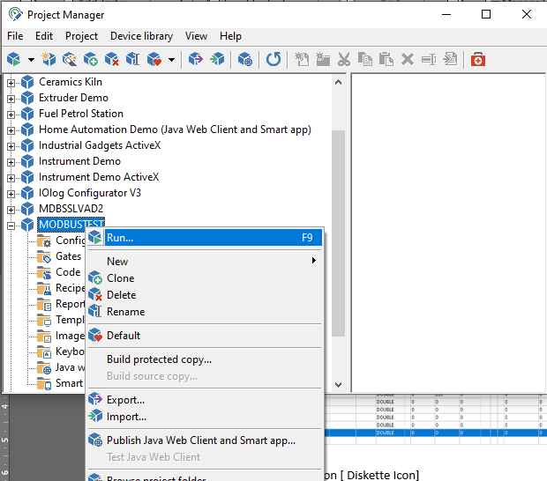

Once it starts to run the screen will change to this.



Simply use the Supervision Tab to access the gates

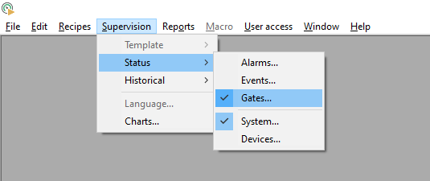

A new window will come out to show the input status

Select Numeric under the Type of Gate

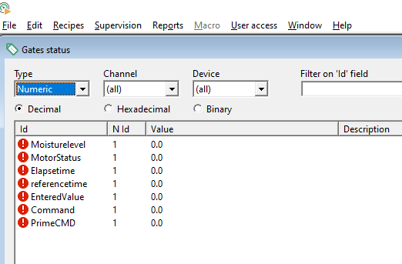

If there is a problem in terms of connection this should show up. You can see its all red.

# Project 2. Build your assigned project

1. Draw Lots on which group does what particular project.
2. Write down the description of what your project does.
3. Create a Block Diagram based on the Description.
4. Create an Input-Process-Output Table to define your device I/O needs and the internal process.
5. Create a proposed Wiring Diagram of how you intended to connect your modules.
6. Create the schematic diagram after you finalize your device wiring. Make sure to update the wiring diagram and block diagram for any additional devices that you may need to do your implementation.
7. Create the Bill of Materials for your project.
8. Create and finalize any mechanical designs your machine needs to operate. This should be on a separate design sheet under mechanism designs. It should have its own discussion on how it operates in line with the machine you want to build.
9. Work on the Arduino MODBUS, EEPROM and LCD program you need to run your project.
10. Work on a User HMI that can show some details not available on the LCD display about your device condition like remaining charges, hours used, cumulative tally and other stuff that you can see as a technician for the device and not an end user.
11. Test your Circuitry using actual people.
12. Test your HMI on the Hardware Unit you used. Let Students grade the ease of use and the ability to understand the data presented on your HMI thru an after use survey.